ATHARVA COLLEGE OF ENGINEERING

ATHARVA SATELLITE GROUND STATION
“We Innovate Communication,
We Communicate Innovation...”
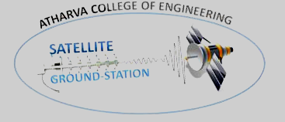
ACADAMIC REPORT
2020-21 & 2021-22 & 2022-23

ACE – GS Report Submitted by:-
1. Mrs. Mahalaxmi Palinje (Incharge faculty ACE – GS)
2. Mrs. Supriya Dicholkar
3. Mr. Sandip Zade

Atharva Satellite Ground Station,
Atharva Educational Trust,
Atharva College of Engineering,
Charkop Naka, Malad Marve Road, Malad (W), Mumbai-400095.
Official Email Id - groundstation@atharvacoe.ac.in

CONTENTS

Sr. No. | Topics | Page No.
1 | INTRODUCTION | 03
2 | COMPLETE SETUP DESCRIPTION | 04
3 | ACE – GS TEAM IN ACADEMIC YEAR 2020-21 | 06
4 | ACE – GS TEAM IN ACADEMIC YEAR 2021-22 | 07
5 | ACE – GS TEAM IN ACADEMIC YEAR 2022-23 | 09
6 | ROAD MAP FOR AY 2022-23 | 10

INTRODUCTION
Atharva Satellite Ground-Station is aimed at creating awareness among the students about the rapidly advancing field of Satellite Communication and Space Technology. The idea was conceptualized by a team of enthusiastic students in 2008, which has being designed and built by succeeding generation in 2012, inaugurated by Dr. Sandeep Baruah, Scientist-E
VigyanPrasar, Department of Science & Technology, Govt. of India. It is being upgraded with innovative new technologies and applications.
A persistent encouragement and support has been provided by Shri Sunil Rane Sir, Executive President of Atharva Group of Institutes & Founder Secretary - AET. Also, constant guidance has been provided by Dr. P. N. Nemade, Director of Atharva College of Engineering; Dr. S. P. Kallurkar, Principal of Atharva College of Engineering.

COMPLETE SETUP DESCRIPTION
Atharva Satellite Ground Station was initiated as a step under IIT Bombay’s first student Satellite "PRATHAM”. The general object of ACE – GS was to receive the signal from the satellite and decode it. The complete link setup would enable the students to track numerous amateur satellites and use the data for further research. Apart from this, the team could use the setup for future endeavors. For this purpose, a link setup was required to be designed and built in an efficient manner. The following is the description of the link setup.
CONTROL ROOM
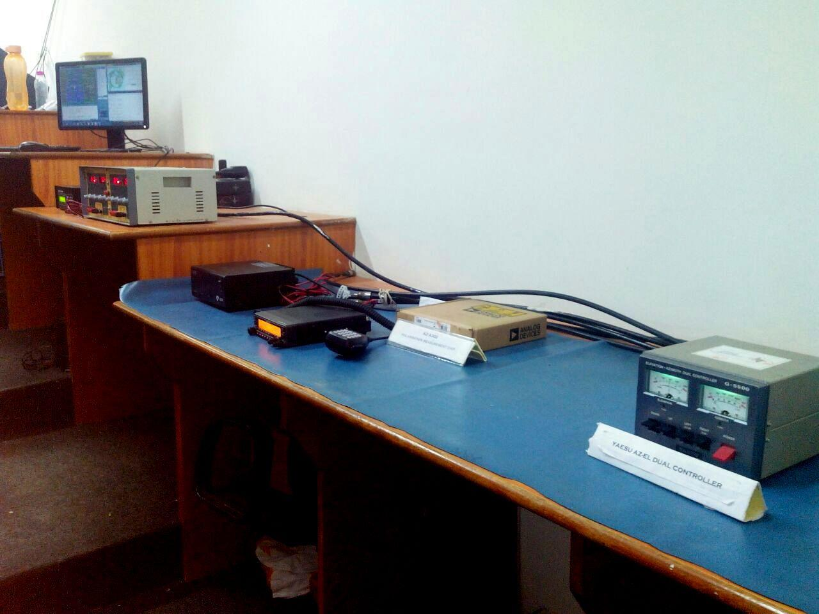
ACE – GS Control Room Setup
- The Control Room would enable the team to carry out automated tracking process.
- The main equipments include:
  - Manual rotor controller.
  - Interfacing hardware and software for automatic rotor control.
  - RF cables and connector system connecting the setup in terrace to the equipments inside the Control Room.
  - Transceiver.
  - Equipments for data processing (for authorized projects).
  - PC and laptops for:
    - Accessing satellite tracking software.
    - Accessing rotor control software.
    - Accessing antenna simulation software.
    - Processing and storing of data.
  - Power supply for various equipments.
- Location of lab: Located on the fifth floor of Phase 1 campus.

TERRACE SETUP
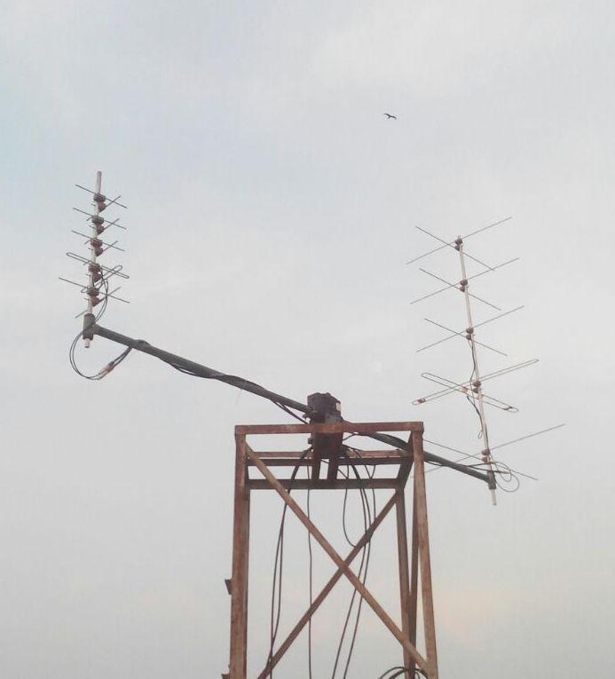
ACE – GS Terrace Setup
- The Terrace would enable the team to carry out automated as well as handheld tracking process.
- The main equipments include:
  - Antenna system:
    - Two Crossed Yagi antennas.
    - Two single plane Yagi antennas.
    - Rotor system.
  - RF cables and connector system connecting the setup in terrace to the equipments inside the Control Room.
  - Low noise amplifiers
- Location of terrace: Located on the western terrace on the fifth floor of Phase 1 campus.

ACE – GS TEAM IN ACADEMIC YEAR 2020-21
• Hitesh Potdukhe - BE EXTC
• Rathin Solanki – BE Electronics
• Tanmay Kulkarni - BE Electronics
• Abhishek Parab – BE EXTC
• Nidhi Lakhani - BE EXTC
• Sawali Korde - BE EXTC
• Harshad Jain - BE EXTC
ACE – GS Project work done in Academic Year 2020-21:Atharva Satellite Ground Station is taking steps towards excellence in satellite communication. Some of our notable work in the last academic year is:
- Designing of antenna.
- YAGI-UDA UHF antenna for 433Mhz with a dipole feed.
- YAGI-UDA VHF antenna for 145Mhz with a folded dipole feed.
- Maintenance of GS such as changing cables connected with the motors, checking connectivity etc.
- Preparation for HAM Radio exam conducted by Ministry of communications, Government of India and acquired their HAM licenses.

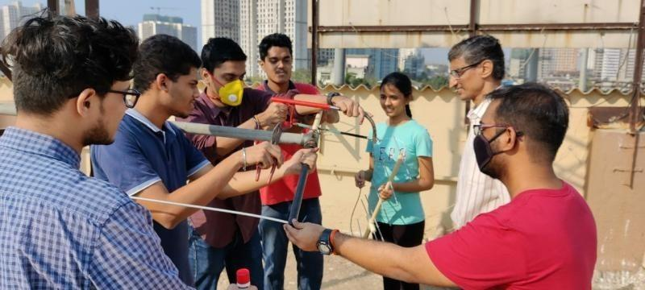
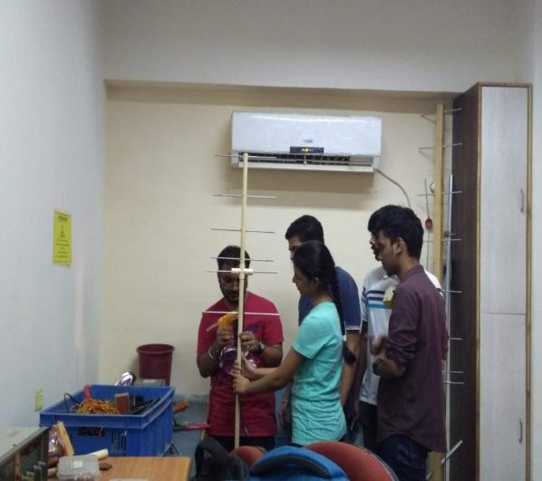

ACE – GS TEAM IN ACADEMIC YEAR 2021-22

- Teesha Sonawane --TE EXTC
- Yash Mehta-- TE EXTC
- Mayur Chauhan -- TE EXTC
- Prerna Gokhale– TE EXTC
- Yash Mhatre – SE EXTC
- Yash Kasar – SE EXTC
- Meet Dhotre – SE EXTC

GROUND STATION EXPANSION ACTIVITY:
- Conducted orientation of ACE GS to students of Dept. of EXTC, ELEX, ELEX in online mode
- Conducted “Designing and Types of Antenna with Introduction to ACE – GS workshop for SE and TE EXTC students
- Ground station expansion activity - Conducted interview, Group discussion and Personal Interview on 7th Dec,2021 for new team selection.
- Newly selected team gave a presentation on “Antenna Designing and Types of Antenna” on 23rd Dec 2021.
- Faculty coordinators of GS conducted interview, Group discussion and Personal Interview on 22nd April 2022 for expansion of GS team for 2021-22 AY.
- Written test on basics of electronics and network theory was conducted , followed by GD and PI.
- The new selected team were also given visit to ACE GS setup and were explained all the set up of GS

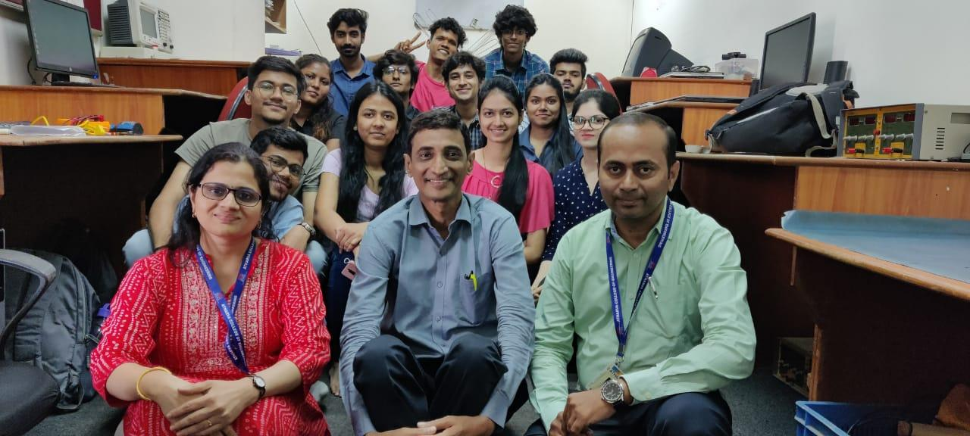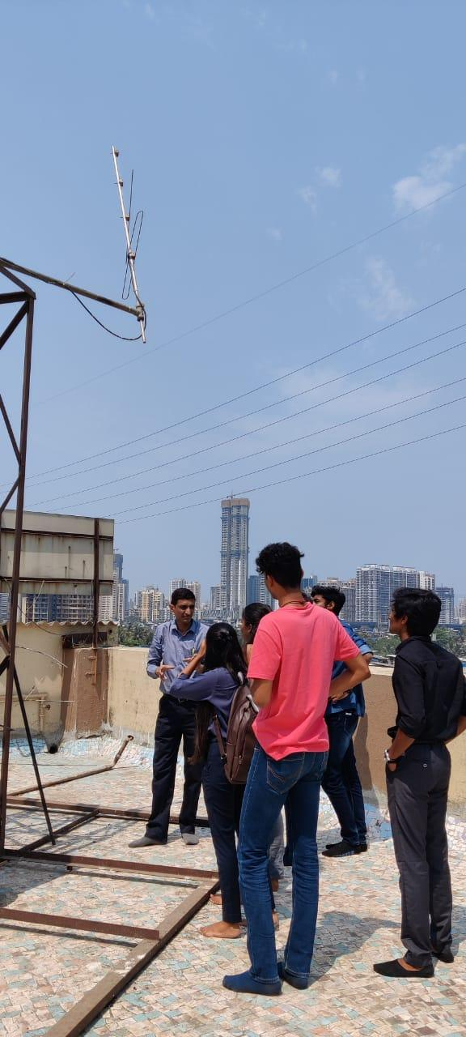

- PROBLEMS FACED:
- Requirements of various tools and gadgets for Ground Station to practice projects on Antennas and Ground Station.
- Security issues of the ACE GS room
SEMINAR IN AY 2021-22
Department of Electronics and Telecommunications Engineering in collaboration with Ground station team of ACE organised webinar on (11th of April 2022) on topic "HAM Radio for Satellite Signal Transmission" by Mr.Jayesh Banatwala, HAM Radio, Secretary Mumbai HAM Radio Institute and his team for the SE and TE students.
a) Session Briefed students about information and demonstration of HAM radio licensing and usage for Satellite Signal Transmission.
b) Collectively around 115 students attended this session which was very interactive.
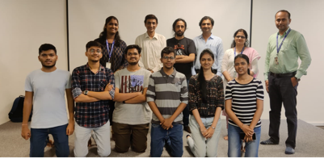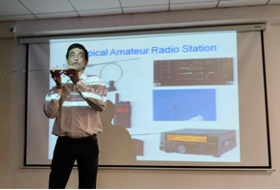
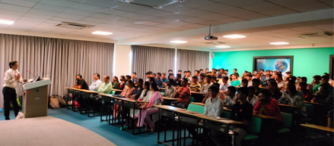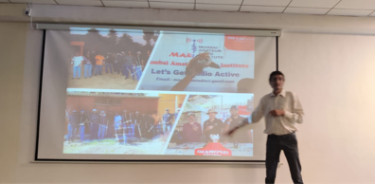
ACE – GS TEAM WORK DONE IN ACADEMIC YEAR 2021-22

- Designing and fabrication of prototype antenna on 23rd Feb,2022.
- On March 4, 2022 dipole Antenna is fabricated by a team which is resonating till 475 MHz.
- Preparation for HAM Radio exam conducted by Ministry of communications, Government of India and acquired their HAM licenses.
- Conducted seminar on "HAM Radio for Satellite Signal Transmission"

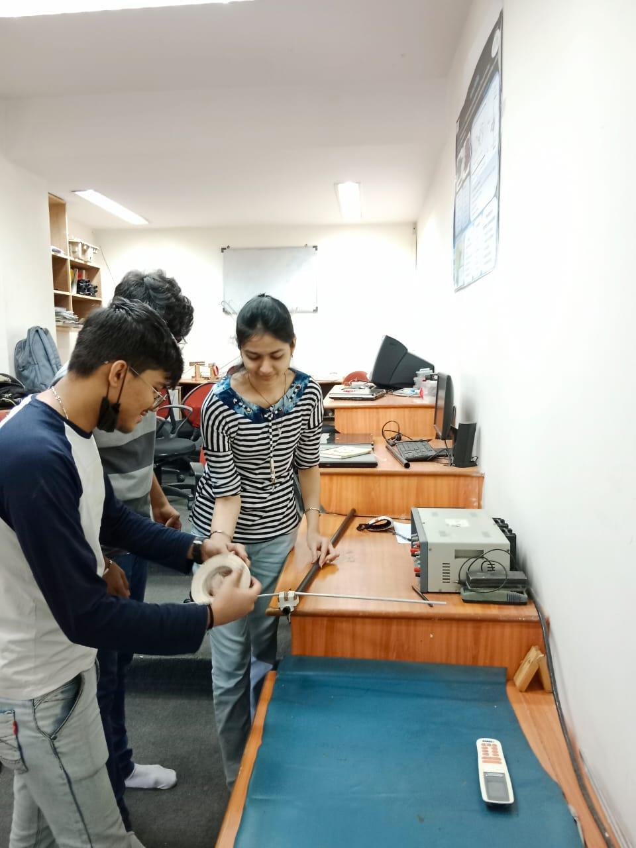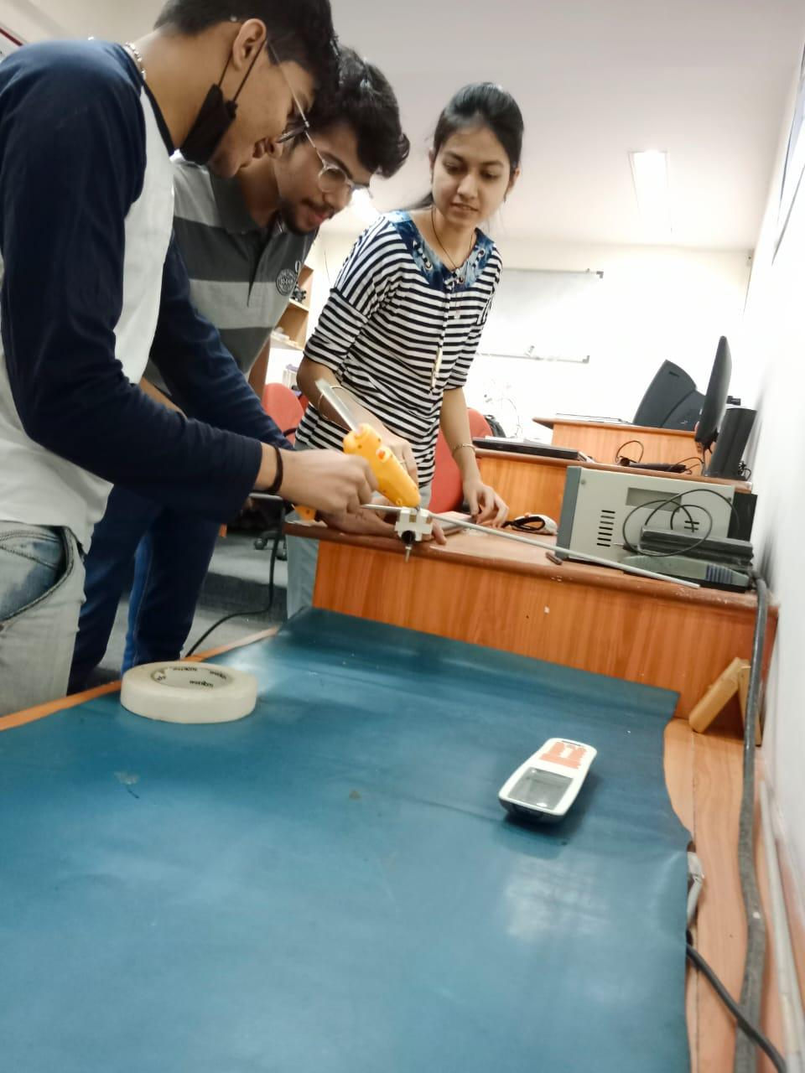
GUEST VISIT IN AY 2021-22
Dr. D P Kothari Sir, Former Director of I/C IIT Delhi , Director Research and Professor, SB Jain Institute of Technology, Management and Research, Nagpur visited Atharva Ground Station on 22 June 2022 and guided ACE GS students team for their upcoming projects
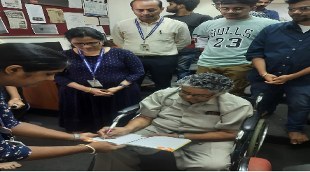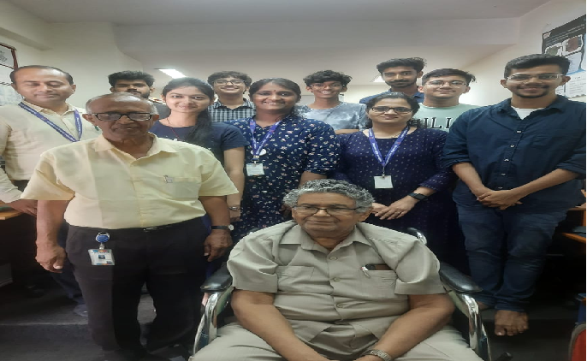

Project Completed by ACE GS team in AY 2021-22
Design and Testing of Egg Beater Antenna : Egg Beater Antenna successfully made and tested by the Atharva Satellite Ground station team of 2021-2022
Egg Beater Antenna as it is omnidirectional and consist of two Loops, both the loops are connected to each other with RG 58,(50 ohms) it should be quarter wave length , Solder outer shield at both the end and the centre conductor connects to the loops.
Team Members:
- Mayur Chauhan-EXTC
- Teesha Sonawane-EXTC
- Yash Mehta-EXTC
- Prerna Gokhale-EXTC
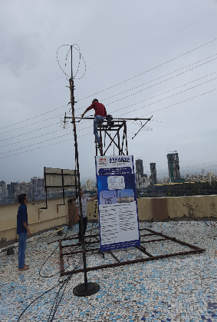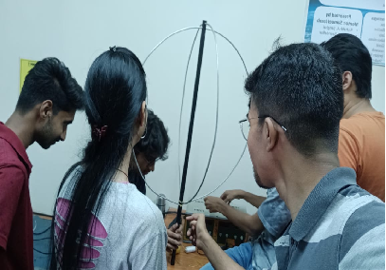
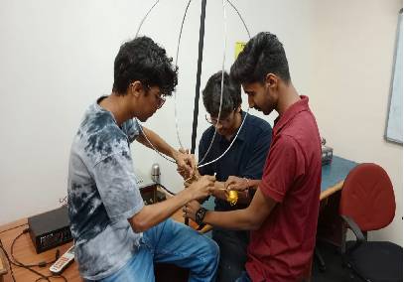

ACADEMIC YEAR 2022-23
- ROAD MAP FOR AY 2022-23
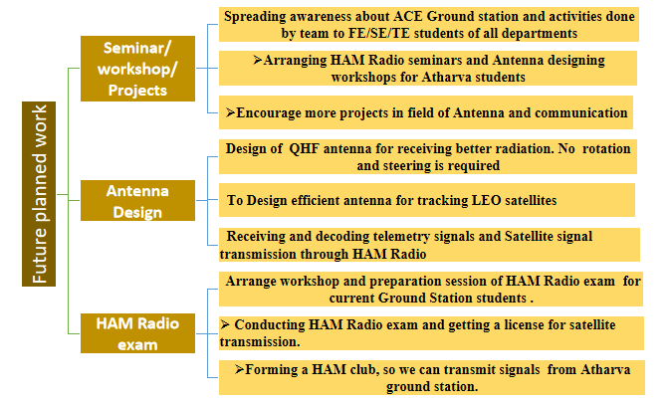
- ACTIVITIES PLANNED IN AY 2022-23
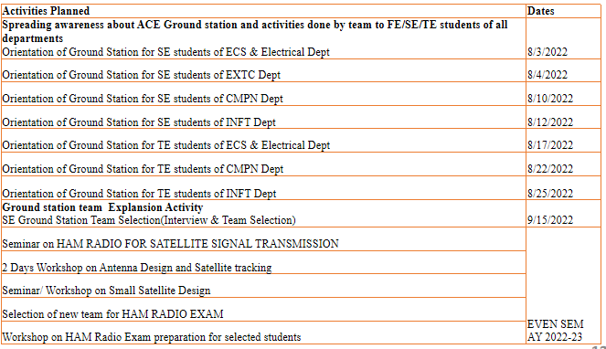
- Spreading awareness about ACE Ground station IN AY 2022-23
- Atharva Satellite Ground Station team has successfully conducted awareness campaign amongst SE students
- Students who had shown interest in joining ACE GS team were taken to visit ACE GS and were explained by the team the work done students in past and present.
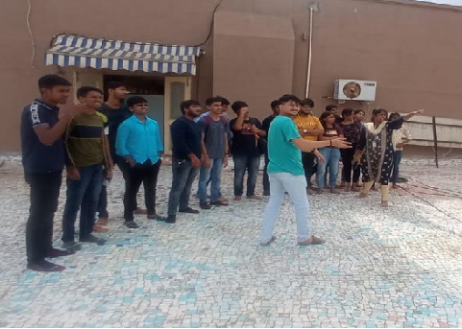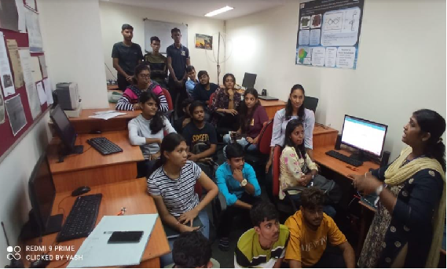
- ACE GS TEAM EXPANSION ACTIVITIES IN AY 2022-23
Atharva Satellite Ground Station team has successfully conducted new team selection for AY 2022-23 on 29th Sept 2022.
Out of 16 SE AND TE students of all branches shortlisted from technical test, 6 students are finalized after GD and PI. We are thankful to Mr.Jayesh Banatwala and students team of ACE GS for helping us in entire process.
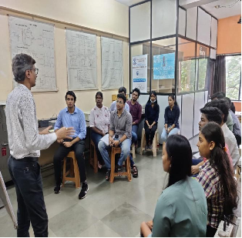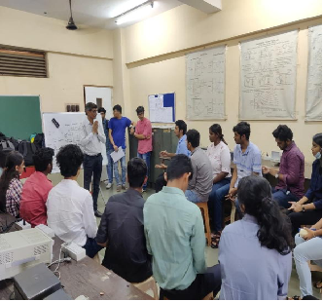
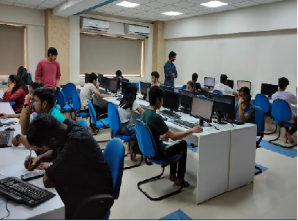
- ANTENNA DESIGNING IN ACADEMIC YEAR 2022-23
Design and Testing of QFH Antenna
QFH Antenna successfully made and tested by the Atharva Satellite Ground station team of 2022-2023QFH antenna is one among various antennas used to capture images from low level non geosynchronous satellites with the frequency of 137 MHz. Team Members:
Yash Kasar-EXTC , Yash Mhatre-EXTC, Rohit Yadav-EXTC , Meet Dhotre-EXTC
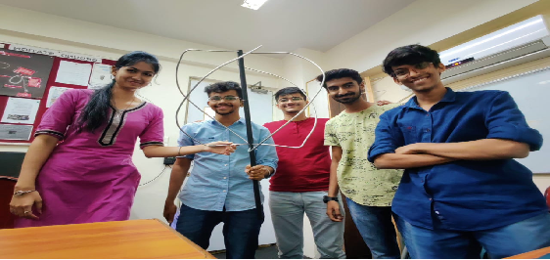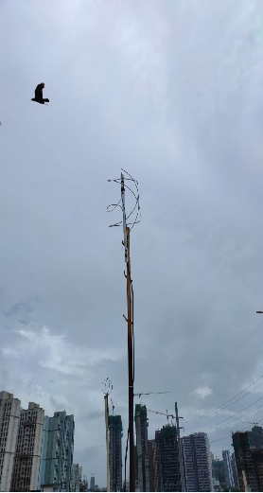
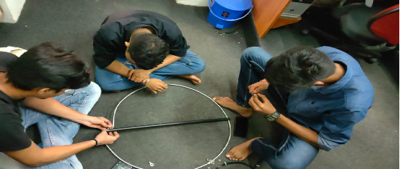
- PREPARATION FOR HAM RADIO EXAM in AY 2022-23
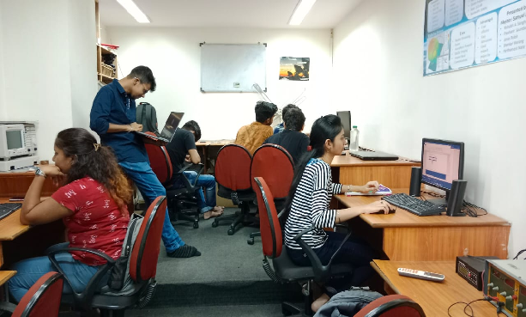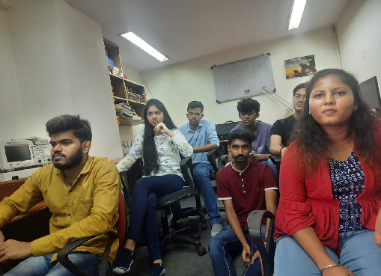
- Antenna Installation for Satellite Tracking
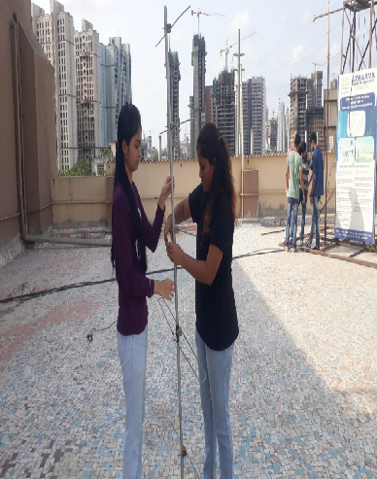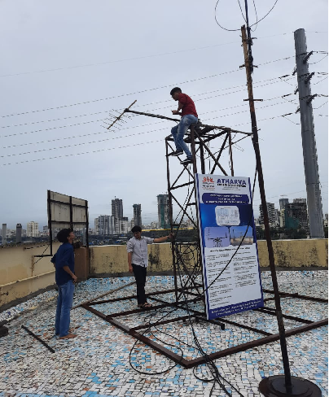
- RESULTS OF SATELLITE TRACKING
ACE GS team received image from the satellite NOAA18 using QFH antenna(Quadrifilar Helix) antenna by interfacing with softwares like AIRSPY, WXTOIMG, GPredict.
The image had outline of India and surrounding areas. This gave exposure to students in antenna designing, software interfacing, tracking of satellite through Gpredict and reception of images from satellite using AIRSPY and WXTOIMG to decode the image received from satellite .
