Department of Humanities anSd Applied Sciences
Ref. No. ACE/HAS/FR/22/2026-27
Date: 05.10.2026

REPORT ON GUEST LECTURE “THE STRANGE WORLD OF QUANTUM COMPUTING”
Event Name | Guest Lecture on “The Strange World of Quantum Computing”
College Name | Atharva College of Engineering, Mumbai
Date and Time | 5TH October 2026, 11:00 AM onwards
Venue | SCR 18, 2nd Floor, Atharva College of Engineering Mumbai
Topic of Event | The Strange World of Quantum Computing
Targeted Audience | First-Year Engineering Students
HOD | Dr. Ritu Sharma
Principal | Dr. Ramesh Kulkarni
Presenters / Faculty | All HAS Department.
Guest Speaker | Dr. Sudhir Ranjan Jain  Professor of Eminence,  Somaiya Vidyavihar University, Vidyavihar, Mumbai

Brief Description of the Event

The Department of Humanities and Applied Sciences organized an insightful guest lecture on “The Strange World of Quantum Computing” for First-Year Engineering students on 5 October 2026. The session was delivered by Dr. Sudhir Ranjan Jain, Professor of Eminence, Somaiya Vidyavihar University, Mumbai, who introduced students to the basic concepts, principles, and potential applications of Quantum Computing, encouraging them to explore emerging technologies beyond conventional computing.

Objectives of the Program
- To introduce First-Year Engineering students to the emerging field of Quantum Computing.
- To provide students with an understanding of the fundamental ideas associated with quantum-based computation.
- To create awareness about the potential of Quantum Computing in solving complex computational problems.
- To encourage students to explore emerging technologies and interdisciplinary areas of engineering and science.
- To inspire students to develop curiosity and interest in future-oriented technological developments.

Topics Covered in the Event

The guest lecture focused on the fascinating world of Quantum Computing, where Dr. Sudhir Ranjan Jain explained its basic concepts and highlighted how quantum systems differ from conventional computing. The session introduced students to the principles, emerging significance, potential applications, and future possibilities of quantum technologies, encouraging them to explore beyond traditional approaches to computing.

Outcome of the Program
a) Students gained an introductory understanding of the emerging field of Quantum Computing.
b) Students developed awareness of the distinctive concepts and possibilities associated with quantum-based computation.
c) The lecture encouraged students to explore emerging technologies and interdisciplinary areas of science and engineering.
d) Students gained insights into the future potential and applications of Quantum Computing.
e) The session stimulated curiosity among students and encouraged them to pursue further learning in emerging technological fields.

Coordinators | HOD, HAS | Principal, ACE
Prof. Abhay Bendekar  Prof. Amrita Trivedi  Dr. Shivani Singh  Dr. Archana Joshi |   Dr. Ritu Sharma |   Dr. Ramesh Kulkarni

Event Photographs :

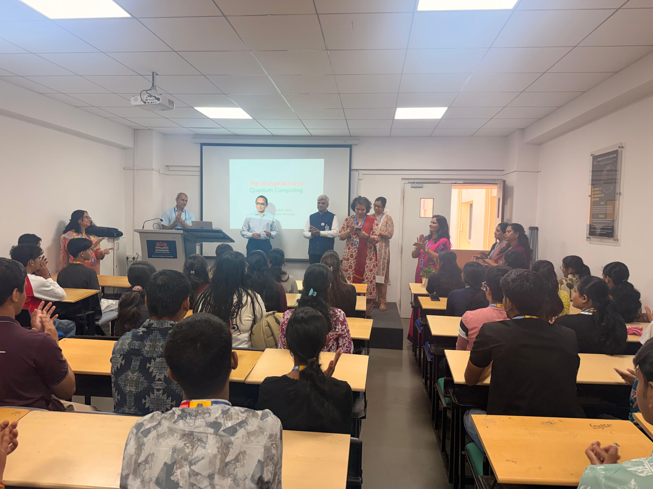 | 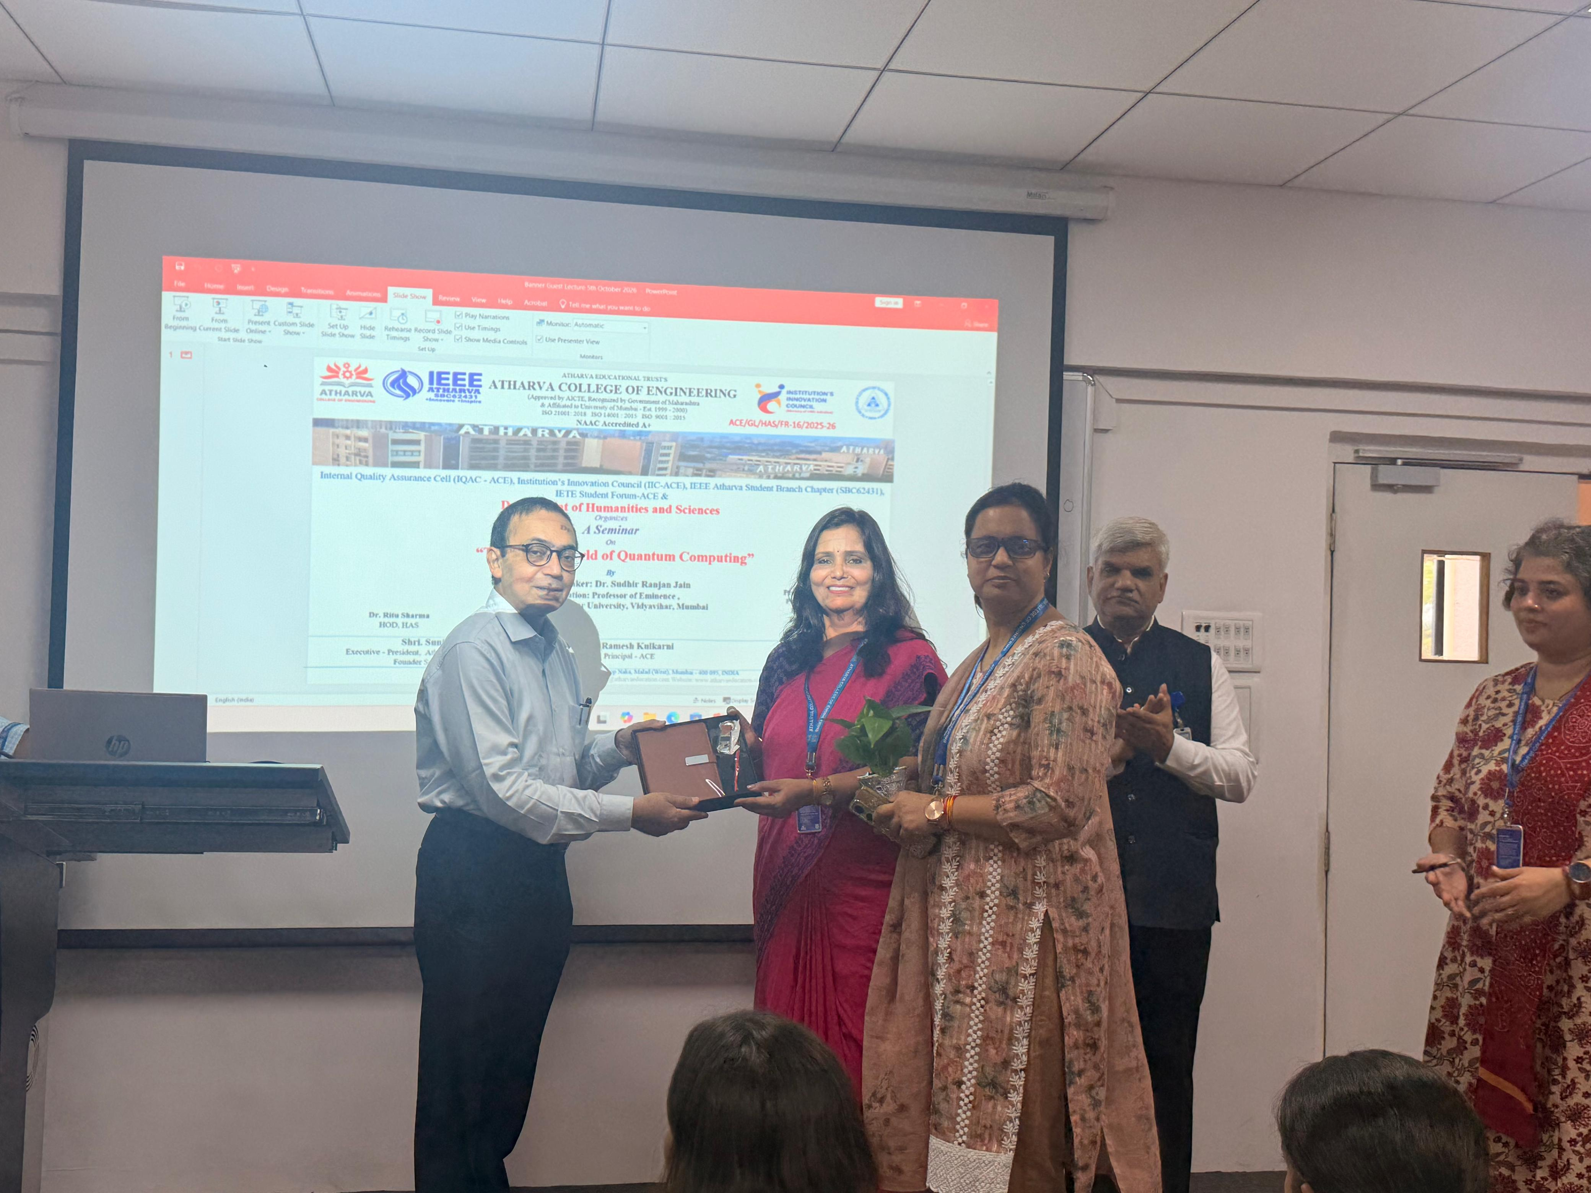

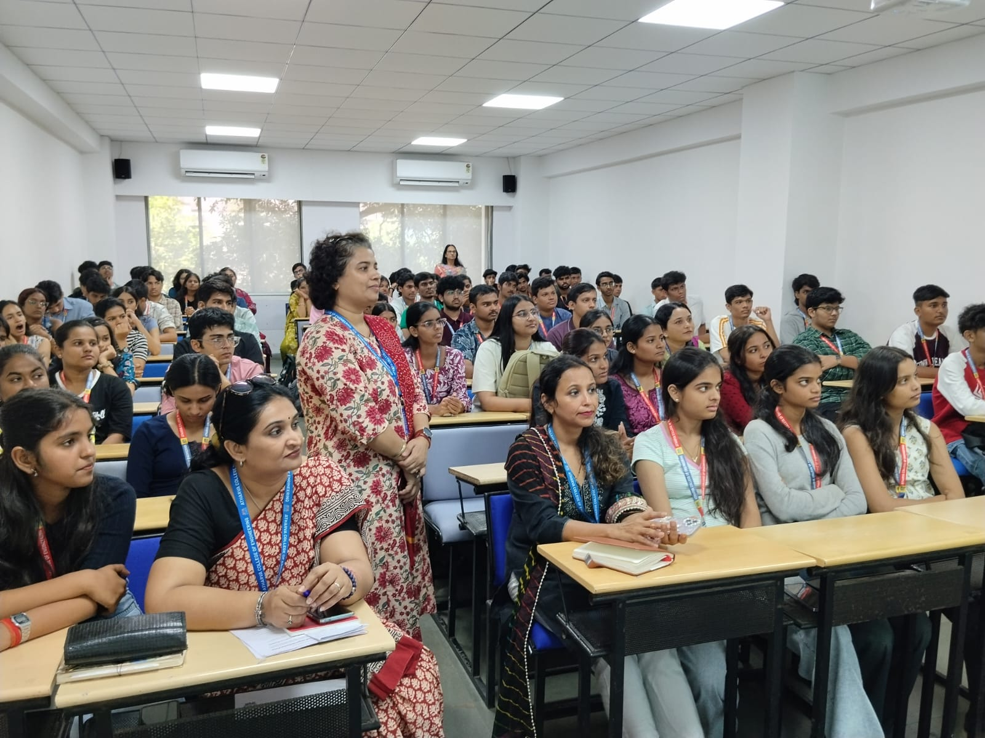 | 