
ACE Electoral Literacy Club

Debate Competition on “One Citizen, One Vote: Equality in Democracy”
Date: 11th February 2026
Venue: Phase 3, Ground Floor, ACE Campus
Organising Department: Electoral Literacy Club

OBJECTIVES OF THE EVENT
● To understand the concept of “One Citizen, One Vote” and its importance in a democratic society.
● To discuss the principle of equality in the electoral process.
● To examine the role of voting in promoting equal participation among citizens.
● To create awareness about the rights and responsibilities of voters.
● To identify challenges that may affect equal participation in elections.
● To encourage students to actively participate in the democratic process.

REPORT
The Electoral Literacy Club, in association with the Student Council, organized a Debate Competition on 11th February 2026 at Phase 3, Ground Floor, ACE Campus. The competition was conducted on the theme “One Citizen, One Vote: Equality in Democracy” with the aim of creating awareness among students about the importance of equal voting rights and responsible participation in a democratic society.
Students from various departments actively participated in the competition and presented their views, ideas, and perspectives on the importance of equality in the electoral process. The debate provided participants with an opportunity to express their opinions, improve their communication skills, and gain a deeper understanding of democratic values.
The event encouraged students to think critically about the principle of equal representation and the responsibilities of citizens as voters. Through their speeches and discussions, participants highlighted the importance of informed voting, equal participation, and respect for democratic values.
The competition was an engaging and informative initiative that provided students with a platform to showcase their confidence, public speaking abilities, and critical thinking skills while spreading awareness about the importance of voting and equality in democracy.

LEARNING OUTCOMES
● Students developed an understanding of the concept of “One Citizen, One Vote.”
● Students gained awareness about equality and equal participation in the electoral process.
● Students understood the rights and responsibilities of citizens as voters.
● Students identified challenges that may affect equal participation in elections.
● Students explored the importance of informed and responsible voting.
● Students enhanced their communication, public speaking, critical thinking, and debating skills.
● Students developed greater awareness of democratic values and responsible citizenship.
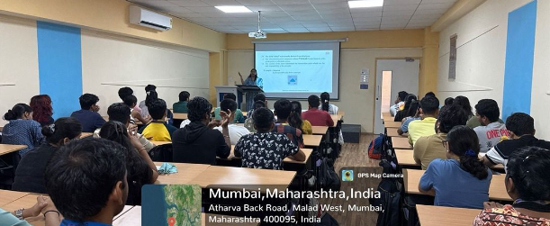

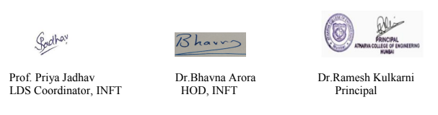

“Importance of Voting in a Democracy”

Date: 17th March 2026
Venue: ACE Campus
Organizing Department: Electoral Literacy Club

OBJECTIVES OF THE EVENT
● To create awareness among students about the importance of voting and electoral participation.
● To educate students about their Electoral and Democratic Rights.
● To encourage students to express their thoughts and ideas through art and creativity.
● To promote responsible citizenship and active participation in the democratic process.

REPORT
The Electoral Literacy Club, in association with the Student Council, organized a Logo Making & Drawing Competition on 17th March 2026 at ACE Campus. The competition was conducted on the theme “Importance of Voting in a Democracy” with the objective of creating awareness among students about the significance of voting and democratic participation.
Students from various branches actively participated in the competition and showcased their creativity through meaningful logos and drawings. The event provided students with an opportunity to express their ideas and perspectives on voting, democracy, equality, and responsible citizenship through artistic forms.
The competition encouraged students to think creatively while understanding the importance of exercising their voting rights. The artworks displayed meaningful messages about democratic values, active participation, and the role of citizens in strengthening democracy.
The enthusiastic participation of students made the event engaging and informative. It successfully provided a creative platform for students to showcase their artistic talents while spreading awareness about the importance of voting.

LEARNING OUTCOMES
● Students gained awareness about the importance of voting in a democracy.
● Students developed a better understanding of Electoral and Democratic Rights.
● Students learned about the importance of responsible and active citizenship.
● Students enhanced their creativity, imagination, and artistic expression.
● Students understood the significance of participating in the democratic process.
● Students were encouraged to use creative expression to spread awareness about voting and democratic values.

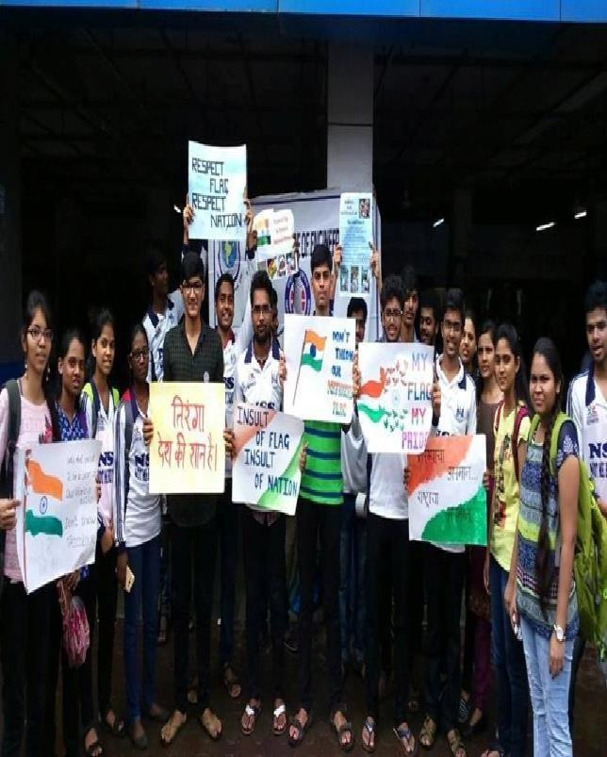
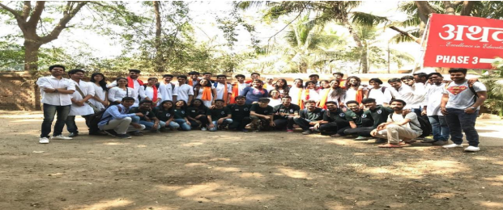

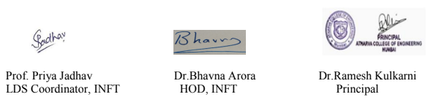

ACE Electoral Literacy Club
Title: Selfie Point

Date: 3rd September 2025
Venue : Phase 1, Lobby.
Organizing Department: Electoral Literacy Club
Objectives
1. To spread the awareness about the upcoming election
2. To encourage voter literacy and voter consciousness.
3. To know the importance of their election voting rights.
Report
Today’s youth are naturally drawn to vibrant and engaging settings, making the concept of a Selfie Point an effective way to connect with young citizens and promote electoral awareness. Recognizing this opportunity, the Election Commission established a Selfie Point to positively engage students while raising awareness about voting procedures and the electoral process.
Nodal Officer Dr. Ritu Sharma and Convener Prof. Bhavna Arora, along with the members of the club, addressed the students on the relevance and importance of voting. They encouraged students to understand their role as responsible citizens and to participate actively in the electoral process.
Students enthusiastically participated by clicking selfies at the Selfie Point and sharing them on their social media platforms, thereby helping spread the message of electoral awareness among their peers and wider communities.
The Selfie Point was established with the objective of encouraging young voters to exercise their right to vote and participate in free and fair elections. It also served as an engaging platform to promote awareness about the electoral process, voting rights, and the responsibilities of citizens in a democratic society.
Outcome
Students have come to recognize the crucial role of voting in selecting leaders and its significant impact on the progress of society.

Photo
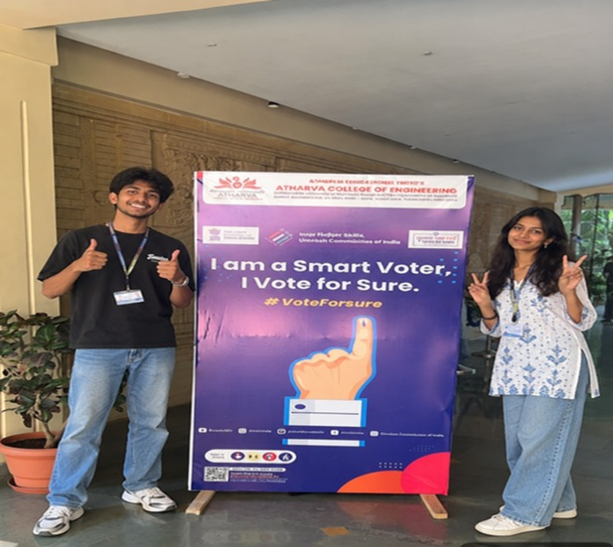 | 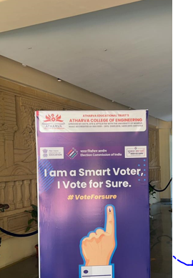
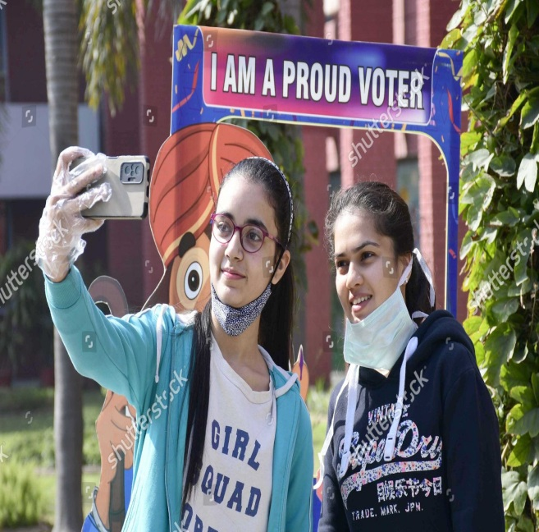 | 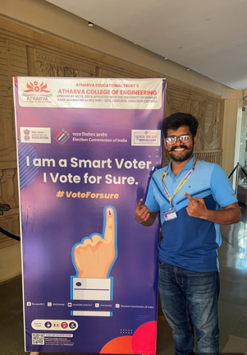
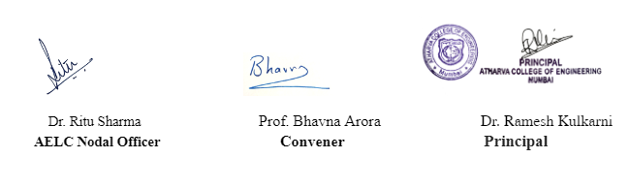
ACE Electoral Literacy Club

Title: Voters’ Information
Date: 25th September 2025
Venue: Phase 1 Smart Classroom
Organizing Department: Electoral Literacy Club
Objectives
1. Voter demographics
2. Voter turnout statistics
3. Voter registration processes
4. Trends in voting behaviour Report
In India, the Election Commission's voter demographics typically include age, gender, race/caste, education level, and income. Older voters often exhibit higher turnout rates in elections. Voter diversity has also increased, with greater participation from minority groups. Voter turnout rates vary significantly depending on the type of election—such as presidential, mid-term, or local elections. The Voter Registration Processes include Online registration ,In-person registration at government offices, Mail-in registration forms .
Trends in voting behavior include: an increase in early voting and mail-in voting; the growing influence of social media on voter information and engagement; and the polarization of voters along party lines.

Outcome

Students realized the importance of electoral processes and of using their vote to elect leaders for the betterment of society.

Photos
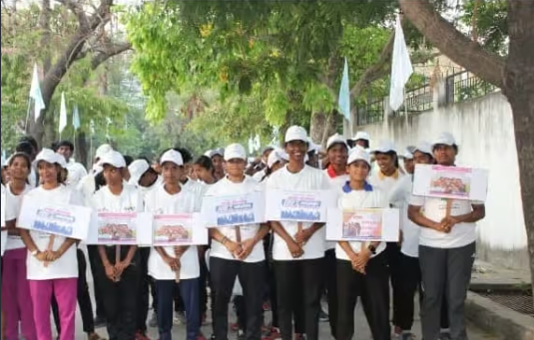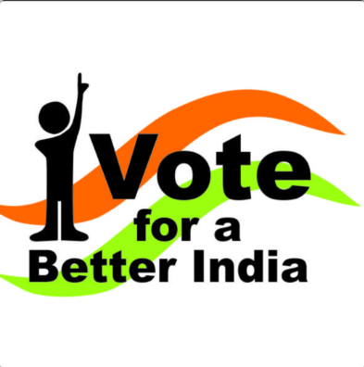

ACE Electoral Literacy Club
Title: Tree Plantation
Date: 20th January 2026
Venue: Phase 3
Organizing Department: Electoral Literacy Club
Objectives
1. To promote environmental awareness & civic responsibility in students.
2. To encourage active student participation in sustainability initiatives, foster a sense of social and environmental duty
Report
.
Dr. Ritu Sharma and Prof. Bhavna Arora addressed students about the relevance and importance of tree plantation and encouraged them to actively participate in the tree plantation drive. The Electoral Literacy Club, under the Student Council of Atharva College of Engineering, organized a Tree Plantation Drive on 20th January 2026 to promote environmental awareness and civic responsibility among students. Faculty members and student volunteers participated actively, planting 21 saplings of at AUM campus phase 3. The event began with a short address on the importance of afforestation, followed by the plantation activity, and concluded with a vote of thanks.
Outcome
The initiative fostered active participation from students across departments and reinforced the values of environmental responsibility and community service.
Photos
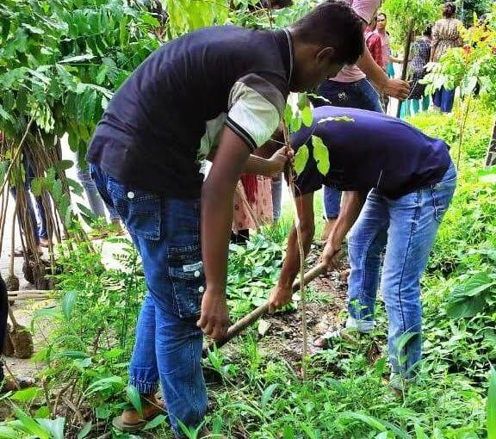
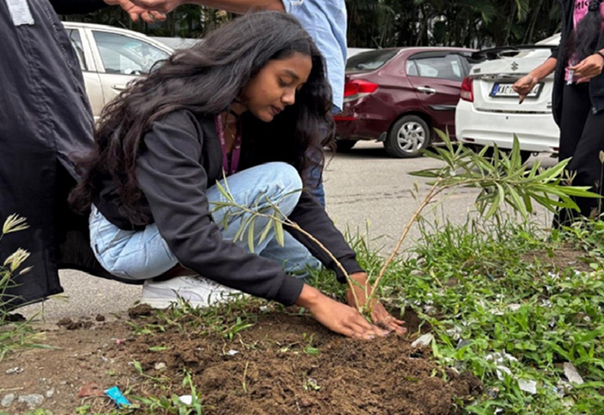

ACE Electoral Literacy Club

Title: Young Voters Yuva Mohatsav

Date: 19/08/2025

Venue: ACE Campus

Organizing Department: Electoral Literacy Club

OBJECTIVES OF THE EVENT:
- To aware students about the importance of Voting Rights & related topics through Young VotersYuva Mohatsav.
- To aware the students about the most important among all these, Electoral Democratic Rights.
- To encourage the students to stand for their rights and make people aware about it.

REPORT
The Electoral Literacy Club, in association with the Students’ Council, organized a special activity on 19th August 2025 to promote awareness about the importance of voting. The event was conducted under the theme “Young Voters – Yuva Mahotsav”, with the objective of encouraging students to understand and exercise their fundamental right to vote.
Students from different branches and departments actively participated in the competition and showcased their creativity through various activities. The event provided an opportunity for students to express their ideas and perspectives on democracy, voting, unity, and responsible citizenship.
Every student possesses unique talent and creativity, and this event encouraged them to use these abilities to spread an important message about democratic values. It also motivated students to explore the meaning of democracy and understand their rights and responsibilities as young citizens.
Through this initiative, students were encouraged to participate enthusiastically, showcase their talents, and create awareness among their peers about the significance of voting. The active participation of students reflected their interest in the democratic process and their commitment towards becoming informed and responsible young voters.

Learning Outcome
- Students have learnt about the importance of Voting Rights & related topics through Young Voters Yuva Mohatsav
- The students came to understand the significance of casting their ballots in order to choose representatives and so play a significant part in improving society.
- Students were encouraged to stand for their rights.

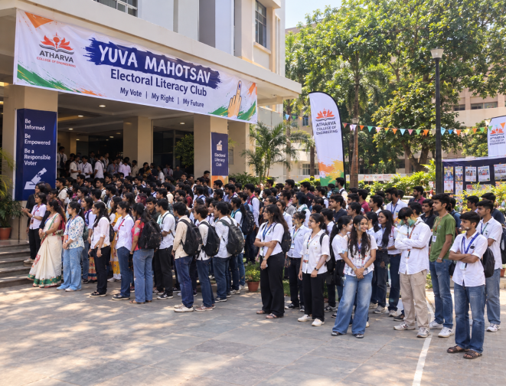
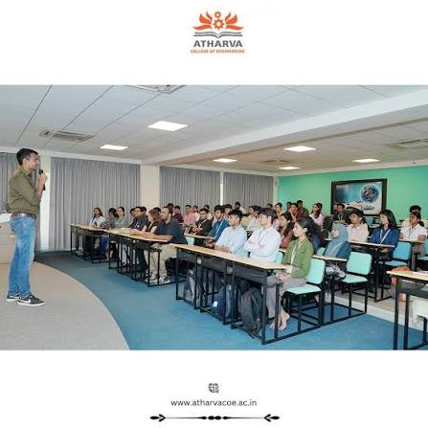

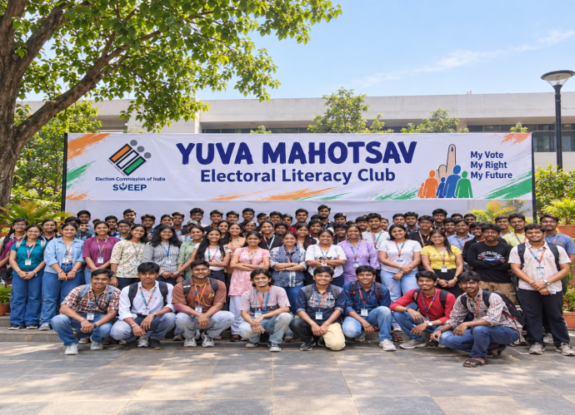
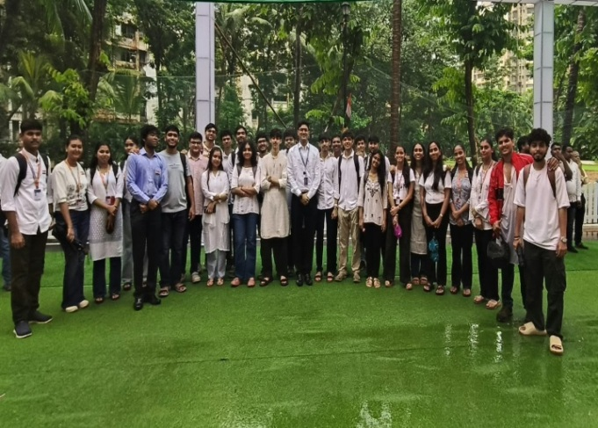

ACE Electoral Literacy Club
Title: Voters’ Pledge
Date: 06th October 2025
Venue: Phase 1
Organizing Department: Electoral Literacy Club
Objectives
1. To educate voters
2. To encourage voter literacy and voter consciousness in India.
3. To aware of voter centric features delivered through the mobile app.
Report
Election commission in India also uses it to strengthen the culture of electoral participation
among young voters. Theme was ‘Nothing Like Voting, I Vote for Sure’.
Dr. Ritu Sharma and Prof. Bhavna Arora addressed students about the relevance and importance of voting and encouraged them to participate in the electoral process. On 06/10/2025, a Voter's Pledge ceremony was organized for youth and students, aligned with the theme "Nothing Like Voting, I Vote for Sure." The event aimed to instill a strong sense of civic responsibility and encourage active participation in the democratic process among young and first-time voters.
The pledge was undertaken to motivate young voters to exercise their privilege to cast a vote in free and fair elections in our democratic country.
This pledge builds a sense of responsibility and awareness about individual rights as a citizen, and also releases that each vote plays a vital role in the electoral process.
Outcome
Students came to understand how important it was to cast their votes in order to choose leaders and so contribute significantly to the advancement of society.
Photos
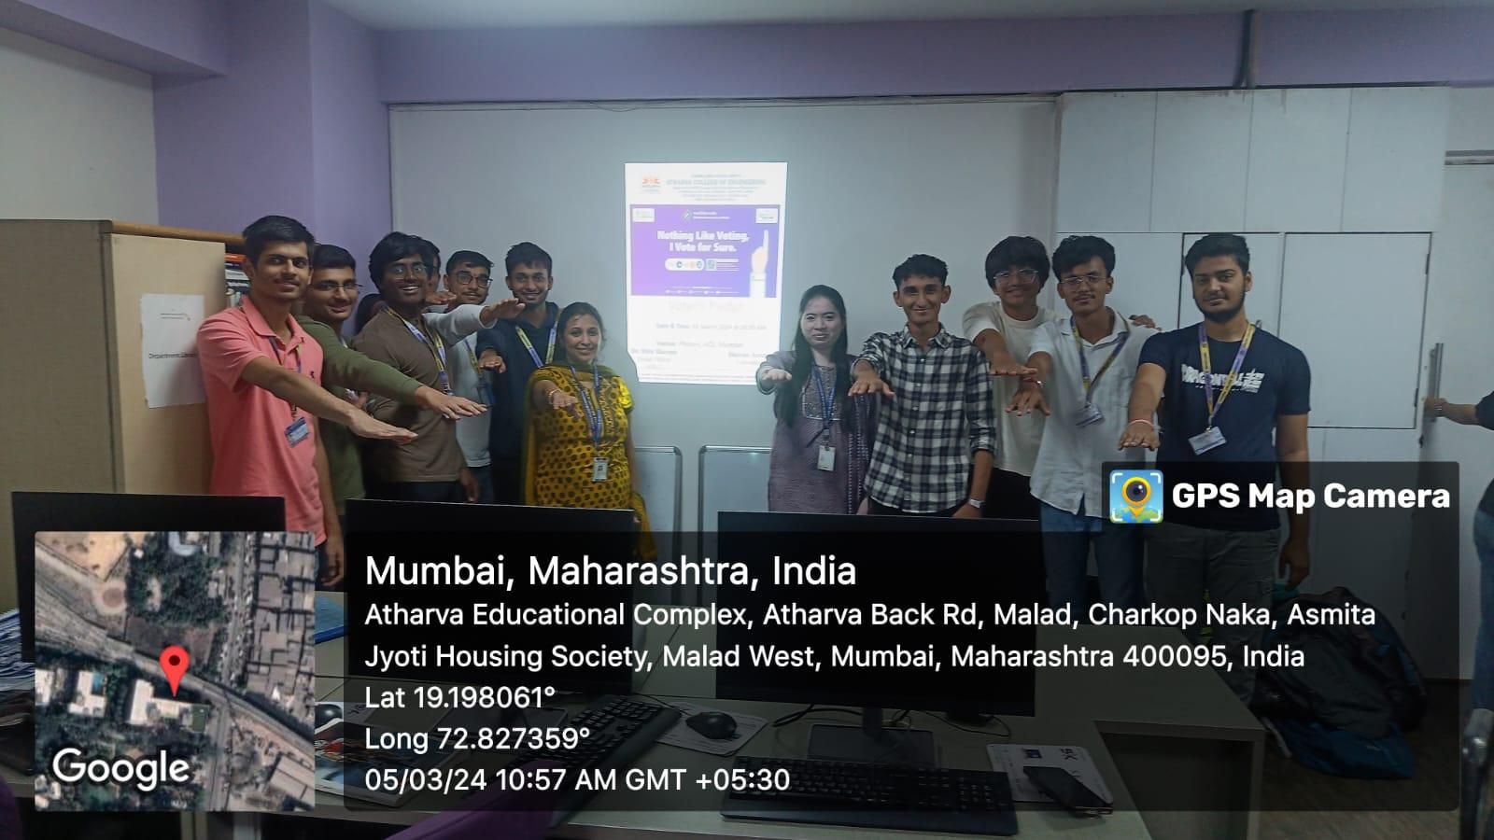
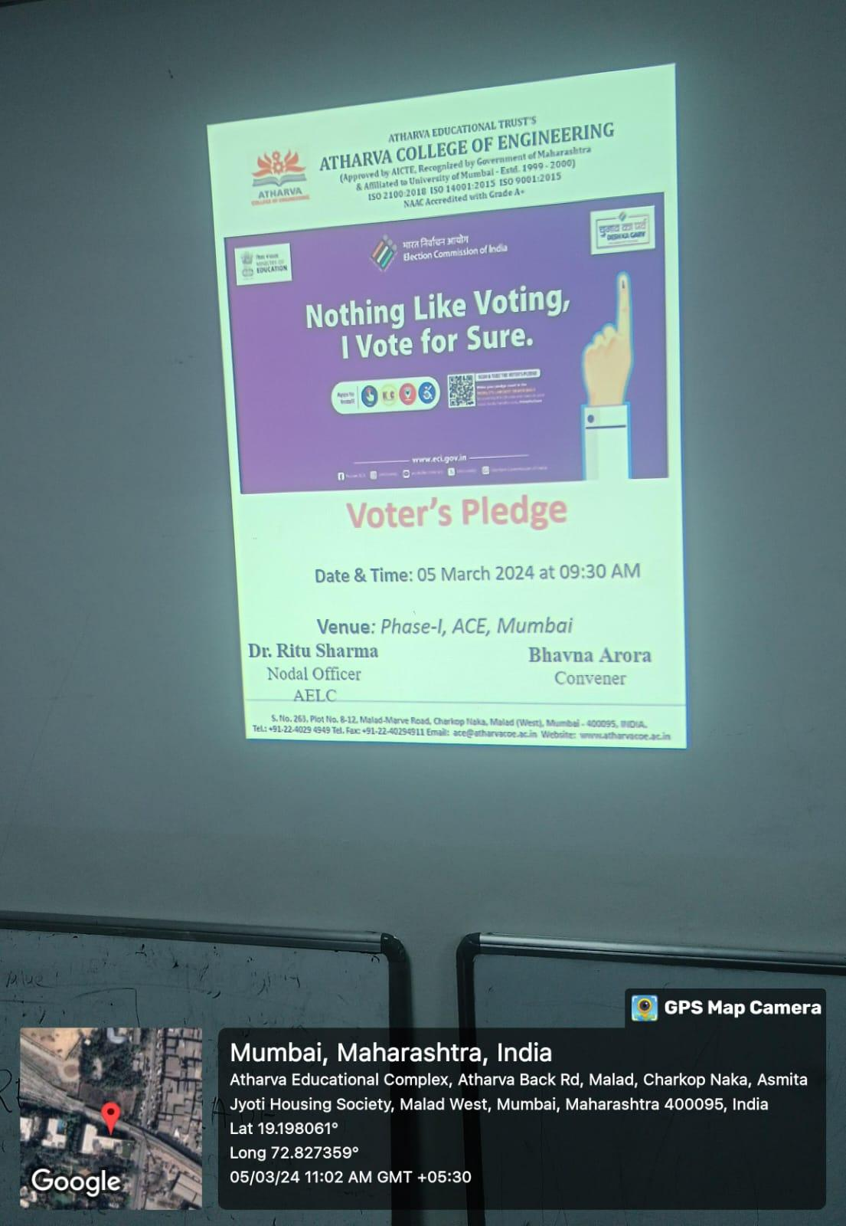
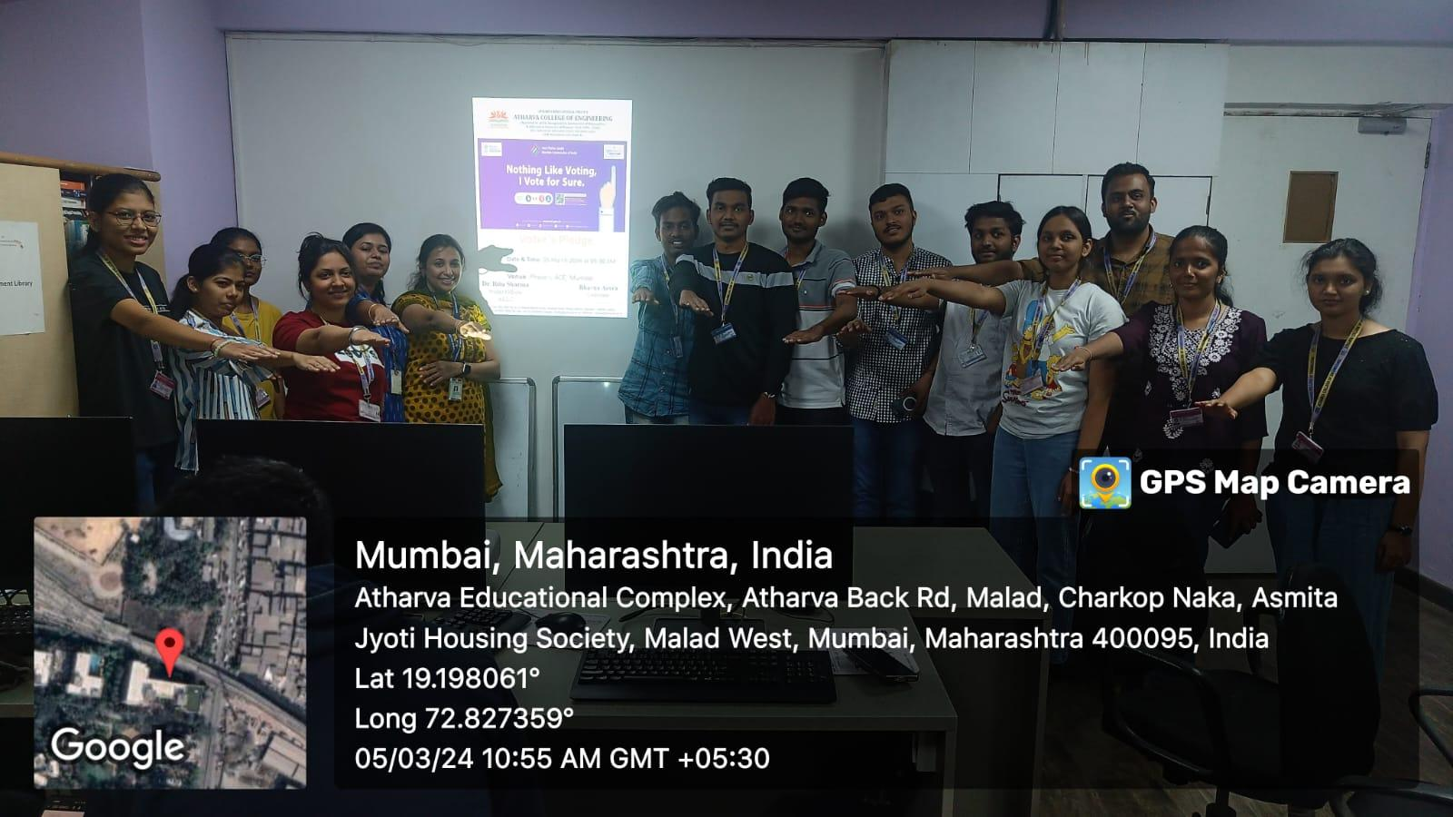

"AI and the Engineer of the Future: Inter-Class Speech Competition"
Title: Report on the Speech Competition on “AI and the Engineer of the Future”
Date: 13 April, 2026
Venue: ACE Campus
Organizing Department: Electoral Literacy Club
OBJECTIVES OF THE EVENT:
- To give engineering students a stage to present their thoughts on artificial intelligence and its role in their profession.
- To help students overcome hesitation and speak confidently before a live audience.
- To develop analytical thinking and the ability to argue a point clearly and convincingly.
- To promote friendly competition and knowledge sharing among students across branches.
REPORT
On 13th April, 2026, the Electoral Literacy Club, together with the Student Council, hosted an Inter-Class Speech Competition on the theme “AI and the Engineer of the Future” at the ACE Campus. The event was planned to get students thinking and talking about how artificial intelligence is changing the engineering profession. The highlights of the day are summarised below.
The competition drew 28 participants from different branches and was held in two stages, a preliminary round followed by a final round. Speakers covered areas such as automation, smart systems, ethical use of AI, and the new skills engineers will need. Marks were awarded for content, delivery, confidence, and the way each speaker connected with the audience.
A panel of faculty members judged the speeches on clarity of ideas, command of language, and stage presence. Eight students qualified for the final round, where they presented thoughtful, well-prepared speeches that held the audience’s attention throughout.
The programme ended with a prize distribution in which the three best speakers received certificates and mementos. The faculty coordinators praised all participants for their effort, preparation, and enthusiasm.

Learning Outcome
Participants became more comfortable speaking in public and learned how to organise their ideas into a clear, well-structured speech. The event also gave them a better understanding of how AI may shape their future careers, while helping them shed stage fear and sharpen their communication skills.

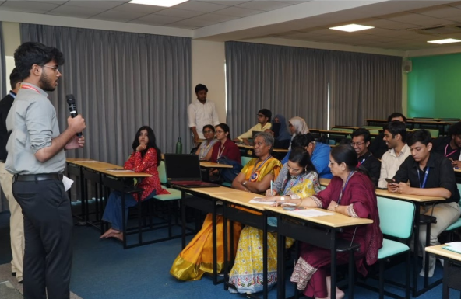

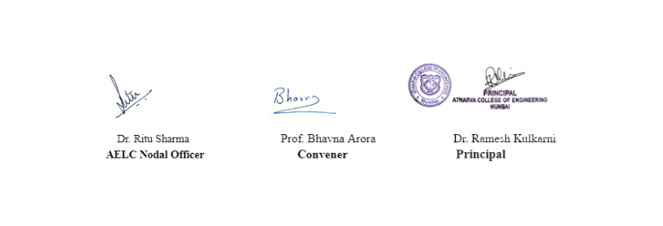

ACE Electoral Literacy Club
Title: Voter Helpline App
Date: 12 September 2025
Venue: Phase 1
Organizing Club: Electoral Literacy Club
Objectives :
1. Informing voters about the Election Commission's app.
2. Encouraging them to download the Voter Helpline App.
3. Providing students with an opportunity to discuss voting rights and familiarizing them with the processes of voter registration and casting a vote.

Report
As part of its ongoing efforts to foster informed and active democratic citizens, the Election Commission of India has launched a new project. The app aims to encourage enthusiastic political participation among citizens and assist them in making ethical and informed voting decisions. Its primary objective is to provide a single point of contact and information for voters across the country.
The 'Voter Helpline App' is a feature-rich application that enables Indian voters to perform various tasks, such as searching for their names in the voter list, submitting forms for voter registration and information updates, downloading digital voter slips with their photos, lodging complaints, learning about contesting candidates, and—most importantly—viewing election results in real-time. Working alongside the club's nodal officer and convener, members informed students about the 'Voter Helpline App'.
.

Outcome
Students learned about the voter-centric features of the 'Voter Helpline App,' which make it a 'one-stop shop' for Indian voters.
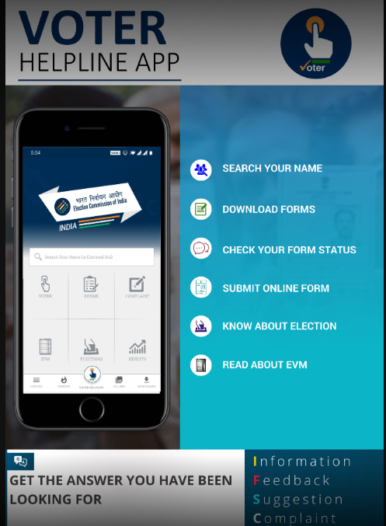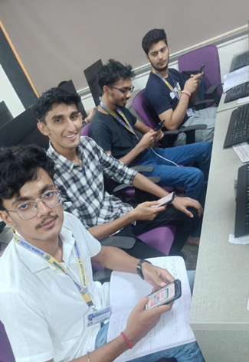
ACE Electoral Literacy Club

Title: National Voters’ Day – Voter Awareness Programme
Date: 20th August 2025 (Wednesday)
Venue: Phase 1 Smart Classroom
Organizing Department: ACE Electoral Literacy Club
Objectives
- To create awareness among students about the importance of voting in a democratic country.
- To educate students about the rights and responsibilities of voters.
- To familiarize students with the voter registration and electoral process.
- To encourage eligible citizens, especially young voters, to participate actively in elections.
- To promote informed and responsible voting among students.
- To highlight the role of youth in strengthening democracy.
Report
The ACE Electoral Literacy Club organized a National Voters’ Day – Voter Awareness Programme on 20th August 2025 at the Phase 1 Smart Classroom. The programme aimed to create awareness among students about the significance of voting and the important role played by citizens in strengthening the democratic process.
The session focused on the importance of electoral participation and encouraged students to understand their rights and responsibilities as voters. Students were informed about the voter registration process, eligibility requirements, electoral procedures, and the importance of ensuring that their names are included in the electoral roll.
The programme also highlighted the significance of making informed choices while voting. Students were encouraged to evaluate candidates and their policies carefully and exercise their voting rights responsibly and independently.
Special emphasis was placed on the participation of young and first-time voters. Students were motivated to actively participate in elections and encourage their family members, friends, and peers to exercise their right to vote.
The session further discussed the importance of ethical voting, voter awareness, and active citizenship. Students were made aware that every vote contributes to the formation of a representative government and plays a role in the development and progress of society.
The programme successfully promoted the values of democracy, responsible citizenship, electoral awareness, and active participation among students.
Outcome
The programme helped students understand the importance of voting and their role as responsible citizens in a democratic society.
Students gained awareness about voter registration, electoral participation, informed decision-making, and the responsibilities associated with exercising their right to vote.
The session motivated students to participate actively in the electoral process and encouraged them to spread voter awareness among their families, friends, and communities.
Overall, the programme strengthened students’ understanding of democratic values and emphasized that every informed and responsible vote contributes to building a stronger democracy.
Photos
Photographs of the National Voters’ Day awareness programme may be inserted here.

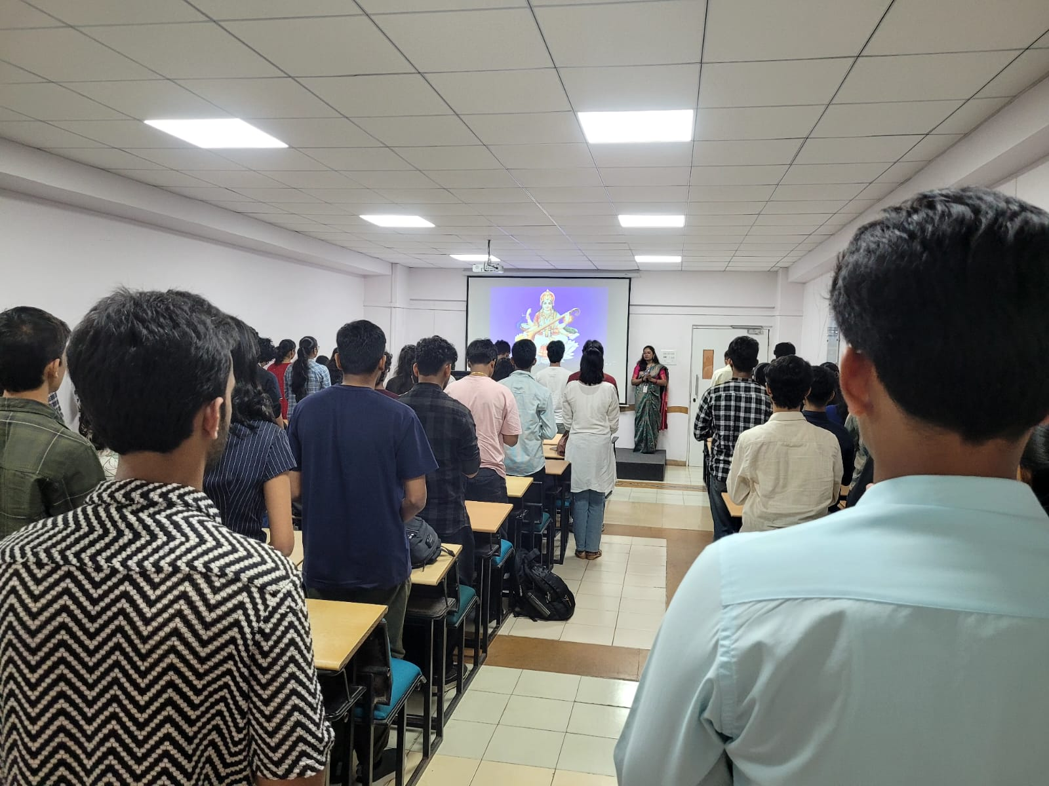
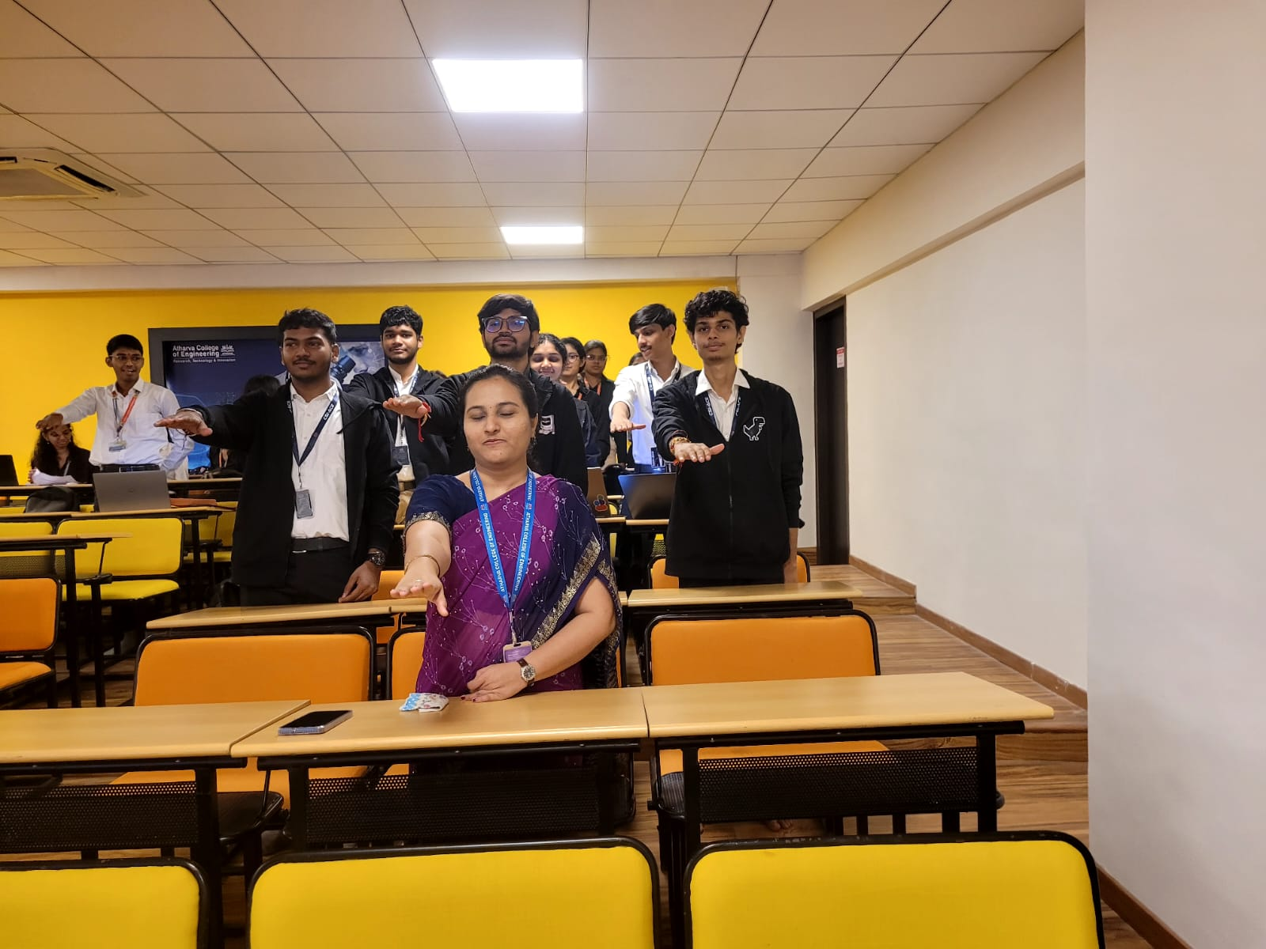

ACE ELECTORAL LITERACY CLUB

ELECTORAL AWARENESS PROGRAMME – 2025
Title: Electoral Awareness
Date: 21st July, 2025
Venue: Smart Classrooms – 2
Organizing Department: Electoral Literacy Club

Objectives
- To develop electoral awareness: To familiarize students with the importance of elections and their role as responsible citizens.
- To create awareness about voting procedures: To help students understand voter registration, polling procedures and the overall process of casting a vote.
- To encourage active participation: To motivate eligible students, particularly young and first-time voters, to participate actively in the electoral process.
- To promote informed citizenship: To encourage students to understand electoral choices, evaluate information critically and make responsible decisions while voting.

Report
The Electoral Awareness Programme was organized by the Electoral Literacy Club to create greater awareness among students regarding their role in the democratic process. The programme focused on helping students understand that voting is not merely a right but also an important civic responsibility. Through the session, students were encouraged to recognize the value of their participation in elections and its contribution to a healthy democratic system.
The programme provided students with an understanding of the basic electoral framework, including the process of voter registration, identification of polling arrangements and procedures followed during elections. Special emphasis was placed on creating awareness among young and first-time voters so that they are adequately prepared to participate in elections when eligible.
Another important aspect of the programme was the promotion of informed voting. Students were encouraged to gather relevant information, examine issues objectively and exercise independent judgement while making electoral choices. The programme aimed to develop a sense of responsibility among students and discourage uninformed decision-making during elections.
The initiative also highlighted the importance of maintaining the integrity and fairness of the electoral process. Students were made aware of the need to remain vigilant against misinformation, electoral malpractices and activities that may adversely affect free and fair participation.
Overall, the Electoral Awareness Programme served as an important platform for strengthening students' understanding of democratic values and civic responsibilities. It encouraged them to become aware, responsible and active members of society and to contribute positively to the democratic process.

Outcomes
- Enhanced Electoral Awareness: Students developed a better understanding of elections, voting rights and civic responsibilities.
- Improved Understanding of Voting Procedures: Participants became more familiar with voter registration and the basic stages involved in the electoral process.
- Encouragement for Youth Participation: The program motivated young and first-time voters to take an active interest in elections.
- Development of Informed Decision-Making: Students were encouraged to assess information critically and make responsible electoral choices.
- Strengthening of Democratic Values: The program promoted awareness of citizenship, participation, accountability and respect for democratic principles.
- Greater Civic Responsibility: Students were encouraged to recognize their role in contributing to an informed, responsible and participative society.
Photos
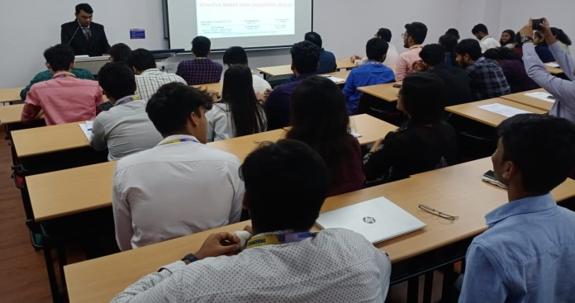 | 