ACE Electoral Literacy Club
Title: Selfie Point

Date: 28th August 2026
Venue : Phase 1, Lobby.
Organizing Department: Electoral Literacy Club
Objectives
1. To spread the awareness about the upcoming election
2. To encourage voter literacy and voter consciousness.
3. To know the importance of their election voting rights.
Report

Today's youth are drawn to vibrant and colorful settings for their selfies. The Election Commission saw this as a chance to create a Selfie Point, which positively engaged students by raising awareness about voting procedures and the election process.

Nodal Officer Dr. Ritu Sharma and Convener Prof. Bhavna Arora along with the members of the club addressed students about the relevance and importance of voting and encouraged them to participate in the electoral process. Students clicked selfies at selfie points and uploaded them on their social media pages.

The Selfie Point was set up to encourage young voters to exercise their right to vote in free and fair elections within our democratic country. It served as a platform to promote awareness about election processes and individual citizen rights.
.

Outcome
Students have come to recognize the crucial role of voting in selecting leaders and its significant impact on the progress of society.

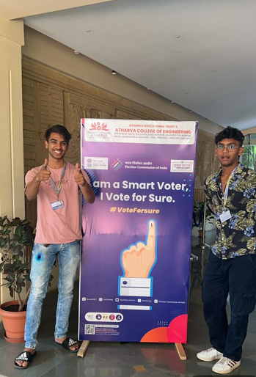 | 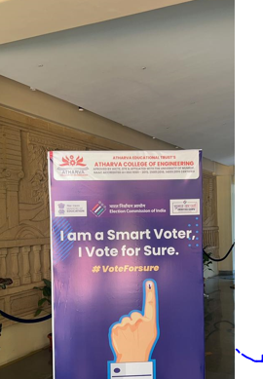
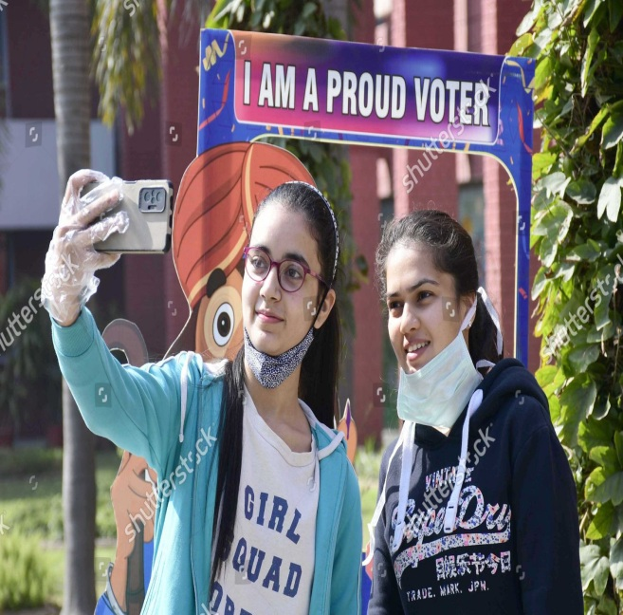 | 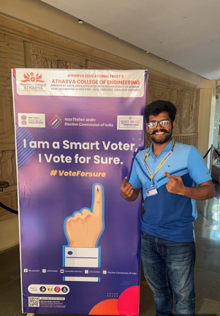
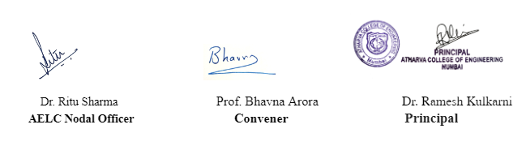

"Voice of Confidence: Inter-Class Speech Competition"
Title: Report on the Speech Competition on “Voice of Confidence”
Date: 12 April, 2027
Venue: ACE Campus
Organizing Department: Electoral Literacy Club
OBJECTIVES OF THE EVENT:
- To provide students a platform to showcase their public speaking and oratory skills.
- To build confidence among students in expressing their views in front of an audience.
- To enhance critical thinking, articulation, and persuasive communication abilities.
- To encourage healthy competition and peer learning among participants from different branches.
REPORT
The Electoral Literacy Club, in association with the student’s council, organized an Inter-Class Speech Competition titled “Voice of Confidence” on 12th April, 2027, with the aim of nurturing public speaking skills and confidence among students. This report outlines the key highlights and outcomes of the competition.
A total of 32 students from various branches registered and participated in the competition, which was conducted in two rounds — a preliminary round and a final round. Participants were given topics ranging from current affairs and technology to social issues and personal growth, and were assessed on content, delivery, confidence, and audience engagement.
The event was judged by a panel of faculty members who evaluated participants on clarity of thought, language proficiency, and stage presence. The final round saw ten shortlisted speakers deliver compelling speeches, engaging the audience with well-researched arguments and confident delivery.
The competition concluded with a felicitation ceremony where the top three speakers were awarded certificates and mementos. Faculty coordinators appreciated the enthusiasm and preparation shown by all participants.
Learning Outcome

Students developed greater confidence in public speaking and learned to structure and present their ideas effectively. The competition also helped participants improve their communication skills and overcome stage fear.
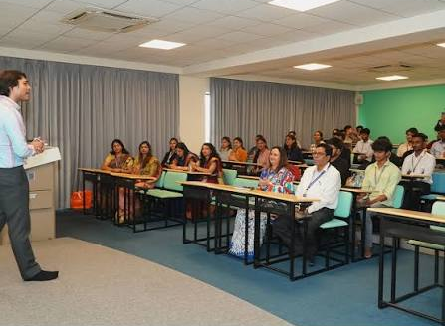

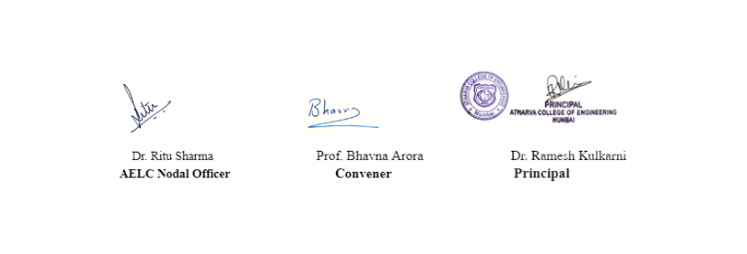

ACE Electoral Literacy Club
Title: Tree Plantation
Date: 14 th January 2027
Venue: Phase 3
Organizing Department: Electoral Literacy Club
Objectives
1. To promote environmental awareness & civic responsibility in students.
2. To encourage active student participation in sustainability initiatives, foster a sense of social and environmental duty
Report
.
Dr. Ritu Sharma and Prof. Bhavna Arora addressed students about the relevance and importance of tree plantation and encouraged them to actively participate in the tree plantation drive. The Electoral Literacy Club, under the Student Council of Atharva College of Engineering, organized a Tree Plantation Drive on 14th January 2027 to promote environmental awareness and civic responsibility among students. Faculty members and student volunteers participated actively, planting 11 saplings of at Atharva College of Engineering. The event began with a short address on the importance of afforestation, followed by the plantation activity, and concluded with a vote of thanks.
Outcome
The initiative fostered active participation from students across departments and reinforced the values of environmental responsibility and community service.
Photos
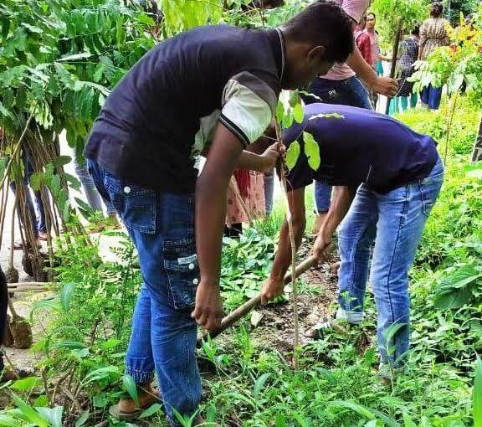

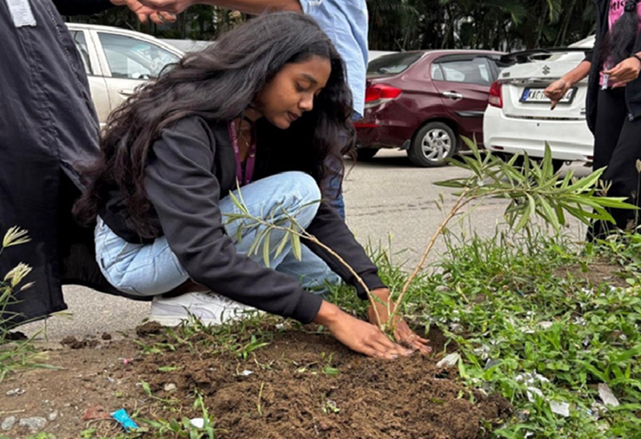

ACE Electoral Literacy Club
Title: Report on Voter Helpline App
Date: 10th Sept 2026
Venue: SCR 1
Organizing Department: Electoral Literacy Club

Introduction:
The 'Voter Helpline App' is a mobile application developed by the Election Commission of India (ECI). Its objective is to provide voters with easy access to election-related services and information via smartphones. The app assists with voter registration, searching for names in the voter list, tracking applications, accessing voting-related information, and availing of other services for voters.
Objectives:
The major objectives of the Voter Helpline App are:
- To make voter services easily available online.
- To help citizens find and verify their names in the electoral roll.
- Simplifying the process of voter registration and updating voter information.
- Providing information about polling stations and elections.
- Providing citizens with the facility to track applications submitted to election officials.
- To enhance transparency and citizen participation in the electoral process.

Major Features:
Search the voter list: Users can search for their names in the voter list using their personal details or information such as their EPIC (Voter ID) number.
New Voter Registration: Eligible citizens can apply online for voter registration. The ECI currently offers an online registration facility for new general voters via Form 6.
Correcting and updating details: Users can apply for corrections to entries, change of residence, and replacement of their EPIC through the available voter service forms.

Application status: Applicants can track the status of their submitted voter service applications.

Polling station information: This app helps voters access their electoral details and information related to voting.
Voter Information and Election Results: This app provides election-related information, including details about candidates and results.
Digital Voter Services: The ECI also provides electronic voter identification services such as e-EPIC, allowing voters to access an electronic version of their EPIC.
Grievance and Resolution Services: Voters can avail themselves of services related to their grievances and issues through the ECI's digital voter-service ecosystem.
How to use the app:
- Download the Voter Helpline app from the Google Play Store or Apple App Store.
- Open the app and provide the required information.
- Select the relevant voter service.
- Enter your EPIC number or other requested details.
- Submit the application or search request.
- Save the application or reference number where necessary.
- Track the application status through the app.
Benefit:
- Easy access: Voter-related services are available via smartphones.
- Time-saving: Reduces the need to visit the election office for routine services.
- Transparency: Application status can be tracked.
- Convenience: Multiple voter-related services are available on a single platform.
- Greater participation: Election-related information is more easily accessible to citizens.
- Digital Governance: Supports the Government of India's move towards paperless and online public services.
- Enhanced Voter Awareness: Provides citizens with election-related information, enabling them to participate more effectively.
Limitations:
- This requires a smartphone and an internet connection.
- Individuals with limited digital literacy may require assistance.
- Providing incorrect personal information could make it difficult to locate electoral records.
- Access may be temporarily affected by technical or server issues.
- Users should exercise caution when entering personal information and use only official ECI apps and websites.

Significance in Indian Democracy:
The 'Voter Helpline App' is a significant example of Information and Communication Technology (ICT) within India's electoral system. By simplifying processes such as voter registration, checking the electoral roll, and accessing other services, the app can reduce administrative hurdles and encourage greater public participation in elections.
The ECI highlights the app's 'Electoral Search' facility as a key feature, enabling voters to search for voter list details using their personal information, EPIC details, or barcode-based functions.
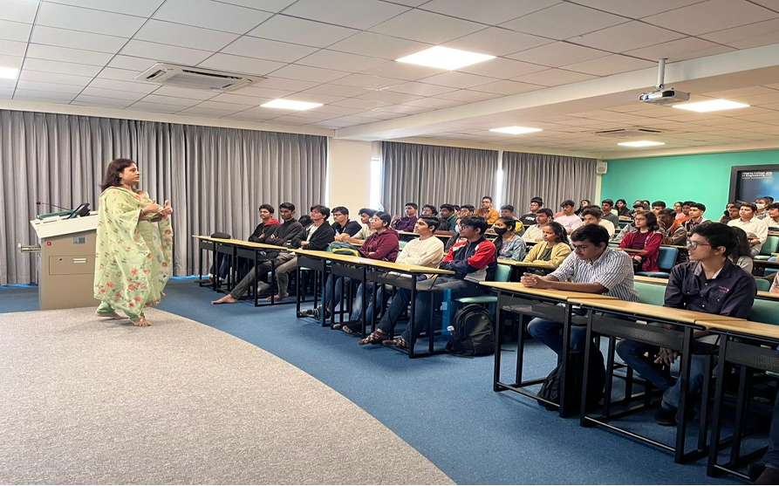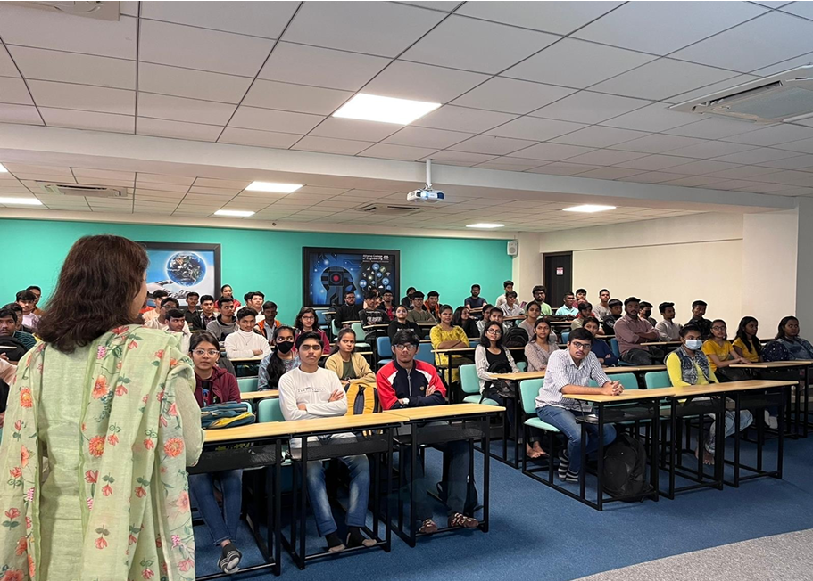

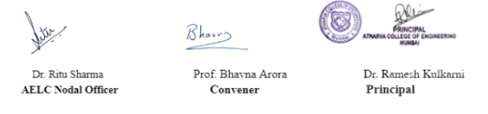

ACE Electoral Literacy Club
Title: Voter's Information
Date: 28th September 2026
Venue : SCR 2
Organizing Department: Electoral Literacy Club

Introduction:
Voter information encompasses the essential details and services that help citizens understand aspects such as voter registration, voter identification, polling stations, constituencies, candidates, and the voting process. In India, the Election Commission of India (ECI) provides these services through its official voter-service platform.
Voter information plays a crucial role in ensuring that eligible citizens can effectively exercise their right to vote and participate in the democratic process.
Objectives of Voter Information:
Its main objectives are:
- Helping citizens verify their names on the voter list.
- Providing information about the voter's constituency and polling station.
- Assisting with new voter registration.
- Facilitating the correction and updating of voter details.
- Providing information about elections and candidates.
- Helping voters obtain their digital e-EPIC (Voter ID).
- Providing a mechanism to register complaints and issues.
- Enhancing voter awareness and participation.

Important information for voters:
Information | Purpose
Name | Confirms inclusion in the electoral roll
EPIC Number | Unique voter identification number
Age/Date of Birth | Helps verify voter eligibility
Address | Identifies the correct electoral area
Assembly Constituency (AC) | Identifies the State Assembly constituency
Parliamentary Constituency (PC) | Identifies the Lok Sabha constituency
Polling Station | Shows where the voter has to vote
Part Number/Serial Number | Helps locate the voter in the electoral roll
BLO details | Provides local election-official contact information

The ECI's voter service allows citizens to search for their names in the voter list using their EPIC number, personal details, or mobile number.
Eligibility to become a voter:
According to the Election Commission of India, an individual generally needs to meet the following criteria:
- They must be a citizen of India.
- They must be 18 years of age or older as of the applicable qualifying date.
- They must be an ordinary resident of the concerned area.
- They must not be disqualified under applicable electoral laws.
There are four qualifying dates for determining age-based eligibility: 1st January, 1st April, 1st July, and 1st October.
Voter Registration:
An eligible individual who is not registered as a voter can apply for registration.
The official citizen service portal provides Form 6 for new voter registration. It also offers Form 6A for eligible overseas Indian voters.
Subsequently, the voter can track the status of their application through the official voter service portal.
Correction of voter information:
If there is any error in the voter's details in the current electoral roll, the voter can request a correction.

Form 8 is used for services such as correcting or updating electoral roll details, changing residence, and replacing or updating the EPIC.
Checking online voter information:
Voters can view their electoral details through the ECI's official voter service portal.
This portal offers the following options:
- Search by EPIC number
- Search using personal details
- Search using mobile number
- Find polling station details
- View voter list (electoral roll) information
The ECI also provides the '1950' voter helpline facility to assist voters.
Importance of Voter Information:
Accurate voter information is important because it:
- Ensures that eligible citizens can vote.
- Helps voters reach the correct polling station.
- Reduces errors in the voter list.
- Helps prevent duplicate or incorrect entries.
- Makes electoral services more transparent.
- Encourages citizens to participate in elections.
- Assists in the efficient conduct of elections.
Voter Information and Digital Services:
The Election Commission has significantly increased the use of digital technology to provide voter services. Citizens can access voter list information, register as voters, check the status of their applications, download e-EPIC, and lodge complaints through online platforms.
Digital systems reduce the need for citizens to visit the election office for various everyday services.
How to verify voter information:
Ideally, voters should verify their details before every election:
Step 1: Visit the ECI's official voter service portal.
Step 2: Select the 'Search Your Name in Voter List' option.
Step 3: Enter your EPIC number or other required details.

Step 4: Verify the information regarding your name, constituency, and polling station.
Step 5: If the information is incorrect or incomplete, submit the appropriate online application.
The ECI specifically advises voters to check their names in the voter list, as an individual can vote only if their name is included in the list.
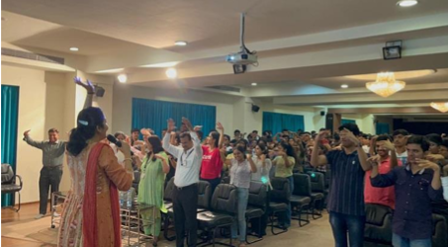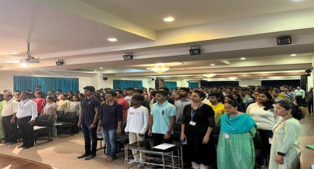
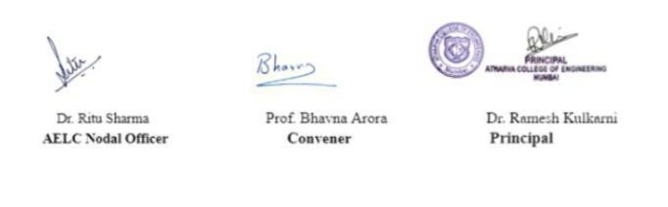

ACE Electoral Literacy Club
Title: Voters’ Pledge
Date: 07 th October 2026
Venue: Phase 1
Organizing Department: Electoral Literacy Club
Objectives
1. To educate voters
2. To encourage voter literacy and voter consciousness in India.
3. To aware of voter centric features delivered through the mobile app.
Report
Election commission in India also uses it to strengthen the culture of electoral participation
among young voters. Theme was ‘Nothing Like Voting, I Vote for Sure’.
Dr. Ritu Sharma and Prof. Bhavna Arora addressed students about the relevance and importance of voting and encouraged them to participate in the electoral process. On 07/10/2026, a Voter's Pledge ceremony was organized for youth and students, aligned with the theme "Nothing Like Voting, I Vote for Sure." The event aimed to instill a strong sense of civic responsibility and encourage active participation in the democratic process among young and first-time voters.
The pledge was undertaken to motivate young voters to exercise their privilege to cast a vote in free and fair elections in a free democratic country.
This pledge builds a sense of responsibility and awareness about individual rights as a citizen, and also releases that each vote plays a vital role in the electoral process.
Outcome
Students came to understand how important it was to cast their votes in order to choose leaders and so contribute significantly to the advancement of society.
Photos
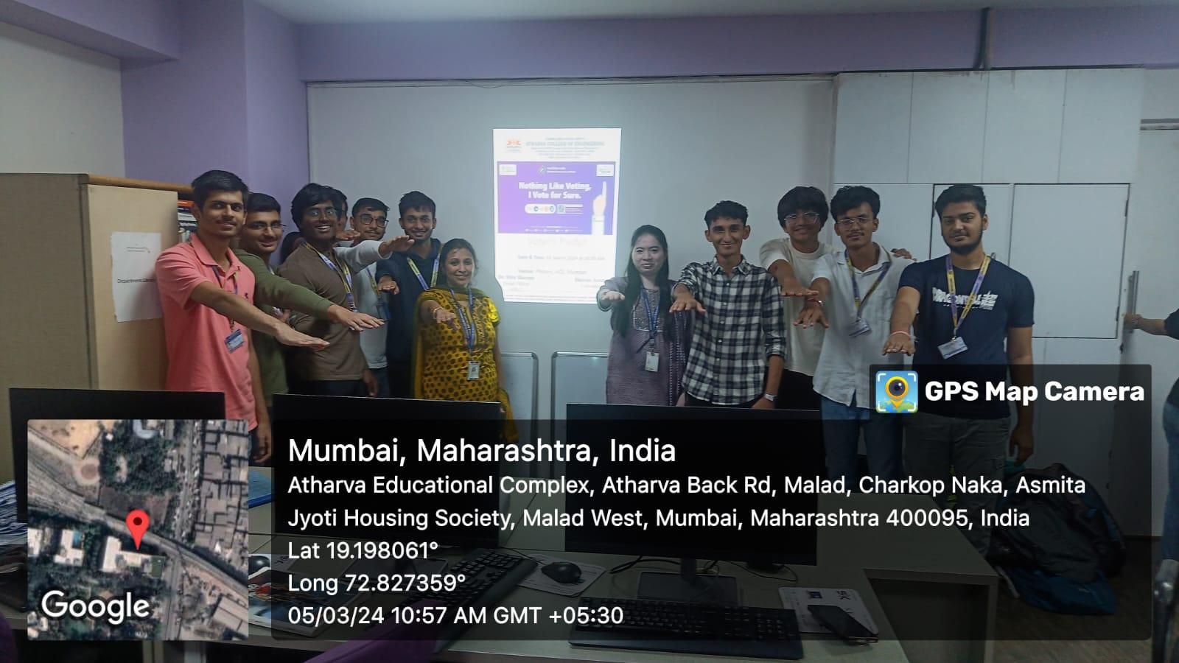
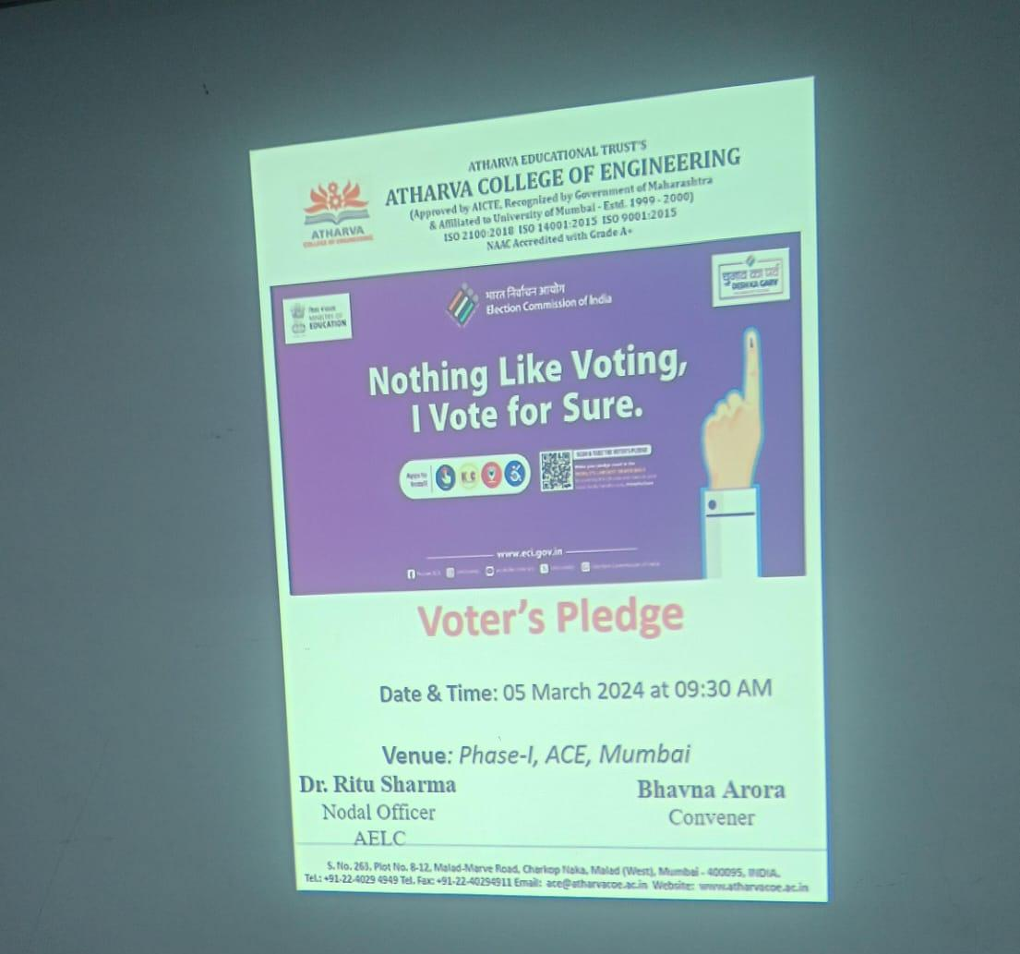
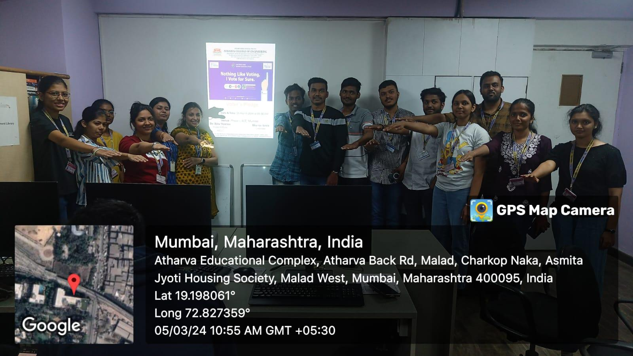

On 07/10/2026, a Voter's Pledge ceremony was organized for youth and students, aligned with the theme "Nothing Like Voting, I Vote for Sure." The event aimed to instill a strong sense of civic responsibility and encourage active participation in the democratic process among young and first-time voters.
All students and youth present at the event took the Voter's Pledge together, committing to vote in every election without fail, to vote without being influenced by money, gifts, or other allurements, and to make an informed and ethical choice based on merit alone. The pledge reinforced the idea that every vote counts and that participation in elections is both a right and a duty of every citizen.
The ceremony helped raise awareness about the importance of voter registration and encouraged students turning 18 to enroll as voters promptly. Through this initiative, the institution reaffirmed its commitment to fostering a culture of responsible citizenship and strengthening electoral participation among the youth, in line with the vision of the Election Commission of India.

ACE Electoral Literacy Club

Title: Young Voters Yuva Mohatsav

Date: 19/08/2026

Venue: ACE Campus

Organizing Department: Electoral Literacy Club

OBJECTIVES OF THE EVENT:
- To aware students about the importance of Voting Rights & related topics through Young VotersYuva Mohatsav.
- To aware the students about the most important among all these, Electoral Democratic Rights.
- To encourage the students to stand for their rights and make people aware about it.

REPORT
The Electoral Club in Association with the student’s council organized a different activity on 19th August, 2026. Voting is a fundamental right given by the government to us .In a bid to create awareness regarding the need to exercise one’s right to vote, was held by the Electoral club on the theme “Young Voters Yuva Mohatsav”. Students from different branches participated in the competition.
Every student has talent to mold themselves and to think creatively, and this event gave all the students from all departments to participate and to showcase something creative with the message to be united and to explore democratic India and stand for their rights.

By this contest students are encouraged to participate in this contest and to shine their talent and also an initiative to spread awareness. This event was conducted, where the number of participants shows their point of view towards the significance of voting.

Learning Outcome
- Students have learnt about the importance of Voting Rights & related topics through Young Voters Yuva Mohatsav
- The students came to understand the significance of casting their ballots in order to choose representatives and so play a significant part in improving society.
- Students were encouraged to stand for their rights.

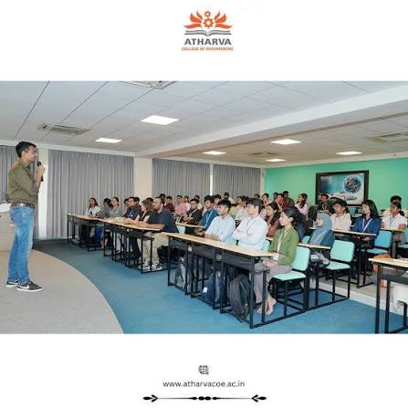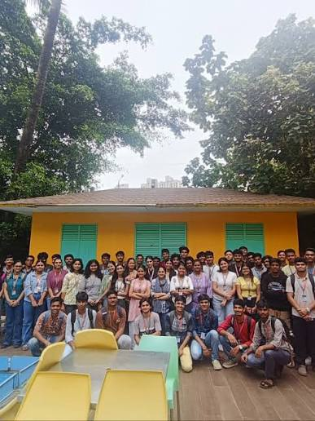

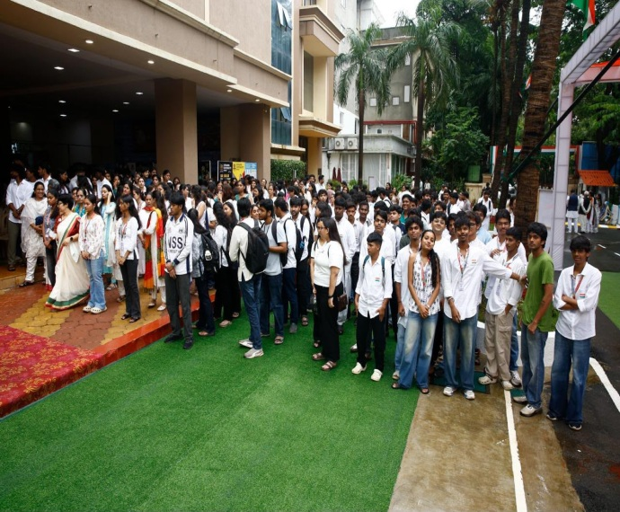
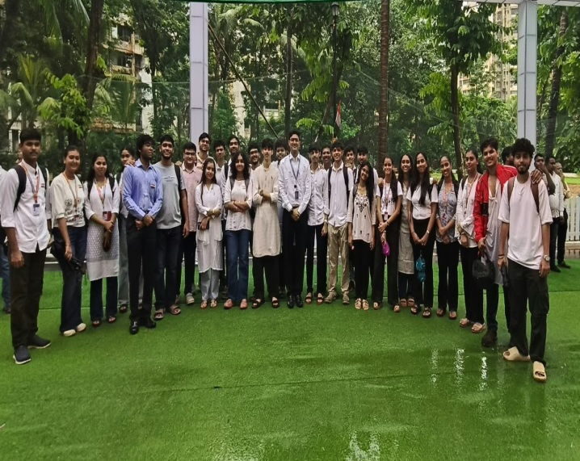

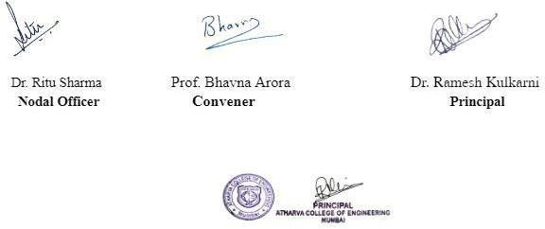

ELECTORAL LITERACY CLUB

REPORT ON NATIONAL VOTERS’ DAY

Date: 11 August 2026
Venue: Smart Classrooms – 2
Organized by: Electoral Literacy Club

The Electoral Literacy Club organized an awareness programme on National Voters’ Day to highlight the importance of voting and responsible electoral participation.
The session introduced students to the significance of voters’ rights, the electoral process, and the responsibilities of citizens. Special emphasis was placed on encouraging young and first-time voters to remain aware and participate responsibly in the democratic process.
Students actively engaged in the session and participated in the interaction.
Outcome:
The programme enhanced students’ awareness of voting rights, electoral participation, and responsible citizenship.

Date: 11 August 2026
Venue: Smart Classrooms – 2
Organized by: Electoral Literacy Club
Coordinator
Electoral Literacy Club

ELECTORAL AWARENESS PROGRAMME – “RIGHT TO VOTE”
REPORT

Date: 20 July 2026
Venue: Smart Classrooms – 2
Organized by: Electoral Literacy Club

The Electoral Literacy Club organized an Electoral Awareness Programme on “Right to Vote” to sensitize students about the importance of voting and responsible participation in elections.
The session covered voter registration, the electoral process, the significance of informed voting, and the responsibilities of citizens. Students actively participated in the discussion and raised queries related to voting and electoral participation.
The programme successfully created awareness among students about the value of their Right to Vote and encouraged them to participate responsibly in the democratic process.

Outcome:
Students gained basic awareness about voting rights, electoral participation, and their role as responsible citizens.

Coordinator
Electoral Literacy Club

“Significance of casting vote”

Date: 11/03/2027
Venue: ACE Campus
Organising Department: Electoral Literacy Club

OBJECTIVES OF THE EVENT
● To educate students about the importance of Voting Rights and related topics.
● To inform students about the importance of Electoral and Democratic Rights.
● To encourage students to stand up for their rights.

REPORT
The Electoral Club, in association with the Student Council, organized a Logo Making & Drawing Competition on 11th March 2027. Voting is a fundamental right granted to citizens, and the competition aimed to raise awareness about the importance of exercising this right.
The theme of the competition was "Significance of Casting Vote," and students from various branches actively participated. The event provided an opportunity for students to showcase their artistic talents and creativity while conveying a powerful message about unity, democratic values, and standing up for one's rights.
The competition encouraged students to engage with the democratic process and use their creative skills to spread awareness about the significance of voting. The enthusiastic participation of students reflected their interest and commitment to sharing their perspectives on the importance of voting in shaping the future of the nation.

LEARNING OUTCOME
● Students learned about the importance of Voting Rights and related topics.
● Students gained awareness about Electoral and Democratic Rights.
● Students were encouraged to understand and stand up for their rights.
● Students developed creativity and awareness regarding the importance of participating in the democratic process.

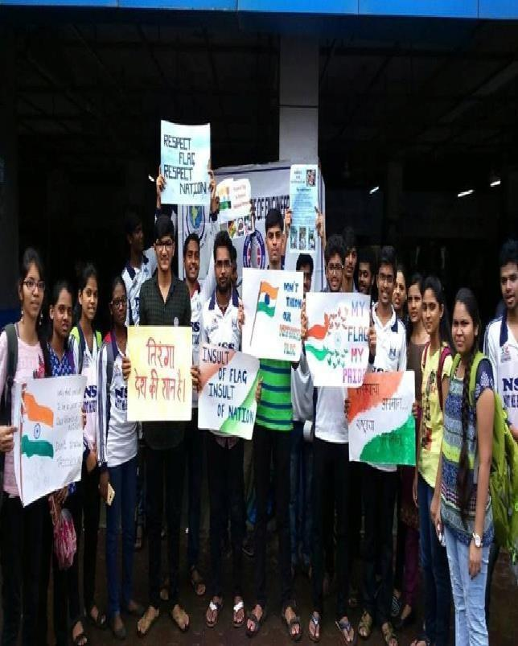
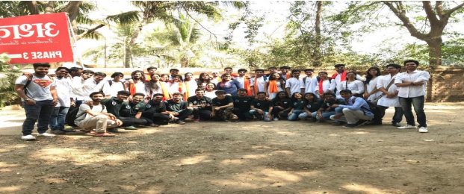

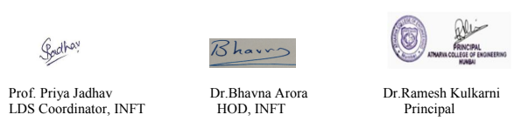

ACE Literature And Debating Society(LDS)

Title: Debate competition
Date: 02nd September 2026.
Venue: Phase 1, Second Floor, ACE Campus.
Organising Department : Literature And Debating Society

OBJECTIVES OF THE EVENT:
The main objectives of the Literature and Debating Society are:

- To develop reading and writing habits among students.
- To improve communication and public speaking skills.
- To encourage creative thinking and expression.
- To develop confidence in presenting ideas and opinions.
- To enhance logical reasoning and critical thinking through debates.
- To promote awareness of literature, language, and current social issues.

REPORT
The Literature and Debating Society in Association with the student’s council organised a Debate competition on 2nd September 2026. A Debate Competition was organized by the Literature and Debating Society to enhance the communication, critical thinking, and public speaking skills of students. The competition provided an excellent platform for students to express their views and present logical arguments on the given topic.
Students actively participated in the competition and presented their opinions for and against the topic. The participants demonstrated confidence, knowledge, and effective communication skills while presenting their arguments. The debate was conducted in a healthy and competitive environment.

Learning Outcome
After participating in the Debate Competition, students were able to:

- Develop effective communication and public speaking skills.
- Improve confidence in expressing their ideas and opinions.
- Enhance critical and analytical thinking abilities.
- Develop logical reasoning and argument-building skills.
- Learn to respect different viewpoints and opinions.

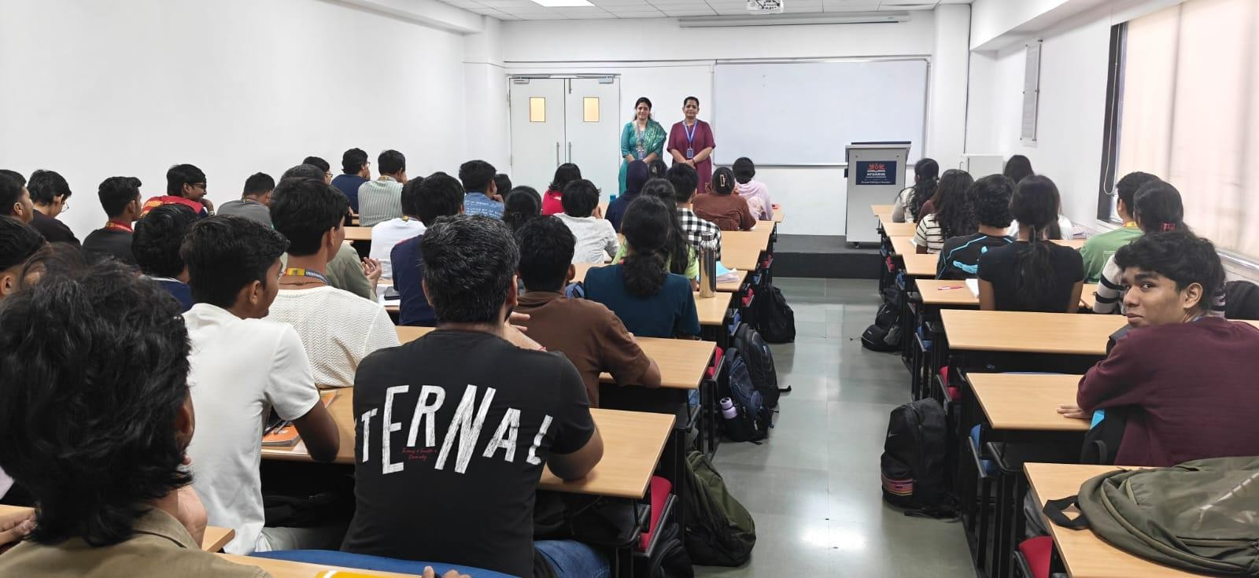

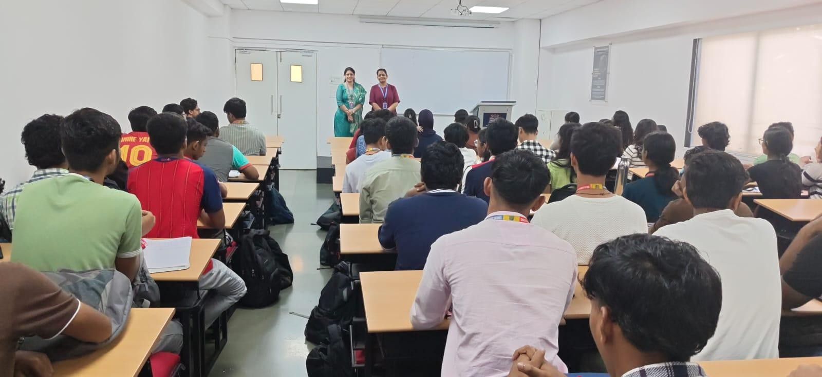





Prof. Priya Jadhav | Dr.Bhavna Arora | Dr.Ramesh Kulkarni
LDS Coordinator, INFT | HOD, INFT | Principal

